What I Love!
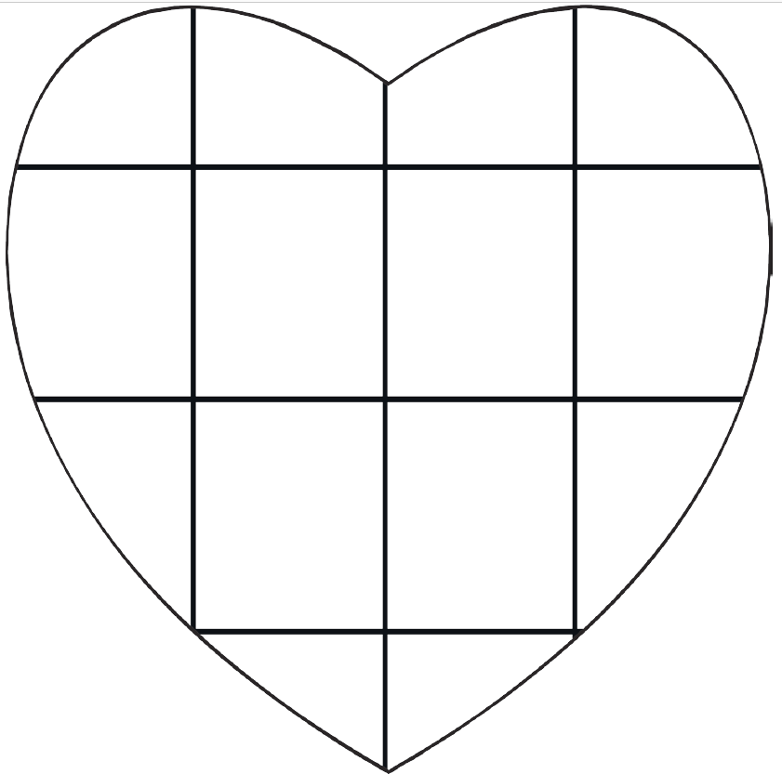
Fill in the heart with pictures or words about what you love!

