Y5 PPA 9th March
Pop Art Mother’s Day Card
Roy Lichtenstein 1923-1997
He became famous for his bright and bold paintings using words that describes a sound such
as 'Thud', 'crash', 'bang' and 'buzz' - onomatopoeia

See the examples below –
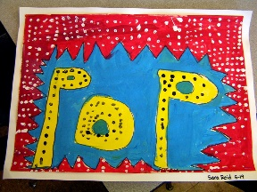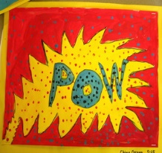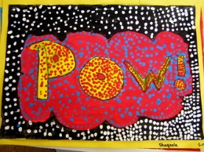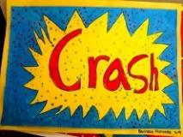

Using this technique, we are going to make a Mother’s Day card.

You will need.
Piece of A4 card
Pencil
Bright coloured felt pens
Black felt pen.

1.Fold the card in half, you can use it either landscape or portrait.
2.Bubble or block write the word ‘Mum’ in large print in the middle of the card.
Watch the link below on block writing.
https://www.youtube.com/watch?v=r1Jit6UuxT0&t=12s
3. Colour the word one colour.
4. Make a pattern around it, then colour it.
5. Then colour the background.
6. Now trace around the colours in black.

See the steps below.

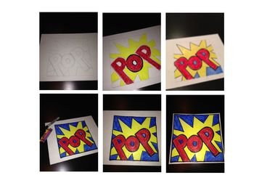

Now write your message for Mother’s Day inside.

