Year 6 Home Learning- Tuesday 09th March
- 9am- Keep fit session with Mr Evans (the video can be found on the school app)
- 9.30 am- Maths- Interpreting line graphs- watch the recorded lesson (found on Google Classroom and the school app) to learn how to solve problems using a line graph. Complete the Holiday problems activity (choose the 1 dot, 2 dot or 3 dot activity). There is an extra challenge activity for you to complete if you have time.
- 10.30am- Literacy- Newspaper reports- Watch the recorded lesson (found on Google Classroom and the school app) to learn how to end a newspaper report and the use of an illustration and caption. Write your own ending examples and create a caption for your newspaper report about the mysterious disappearance of Dr Cuttle.
- 11.30- 12.00- Live catch up session through Google Teams (the invitation has been sent to your HWB email along with instructions on how to join. Please ensure you have read and agreed to the rules and a parent has signed to give permission for you to join)
- 1.00-Reading activities- you can do ERIC reading with a book you have at home, listen to an audio book, read one of your Ereaders on Bug Club, listen to a story being read by a famous person on the following website https://www.storylineonline.net/books/arnie-the-doughnut/ . There are additional reading resources available on Google Classroom if you would like to use them.
- 1.30pm- Welsh/ Helpwr Heddiw- choose a different activity every day from the following: download the Campau Cosmig app and play the games, rehearse the patterns on the language mat, answer the question Beth ydy dy hobi di? using the variety of sentence patterns we have done in class, write down as many questions from the language mat as you can in a minute, play alibi with a family member or play Guess Who? with a family member. There are additional reading resources available on Google Classroom if you would like to use them.
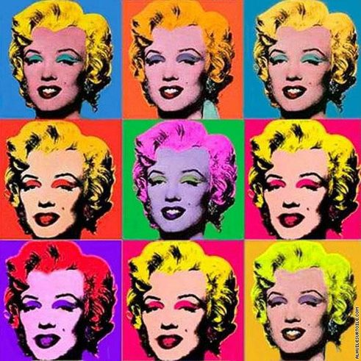
- 2.00-3.00pm- Art- Andy Warhol is a famous Pop artist from the Sixties. Watch the following video clip Art and Design KS2: Andy Warhol’s ‘Marilyn Diptych’ - BBC Teach to learn about Andy Warhol and his famous painting ‘Marliyn Diptych’ which he painted in 1962.

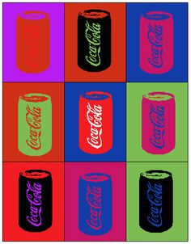
Choose a branded grocery item (e.g. tin of Heinz Baked Beans, Dairy Milk chocolate bar, etc) and create a Andy Warhol inspired piece of artwork. Draw the same item 9 times and use 9 different colours. There is an example using a Coca Cola can below.

