PAGE 1
Year 4 Home Learning 2021 Week 9 – Thursday and Friday
Thursday
Numeracy – warm up - practice times tables on TT Rockstars or BBC Supermovers.
This week we are going to look at volume and capacity of liquids.
- Please have a look at the powerpoint attached.
- I would like you to find some bottles that contain liquid e.g. a bottle of lemonade, orange juice, milk etc.
- Write down in ml what each holds.
- Then can you order them from the lowest to the highest amount.
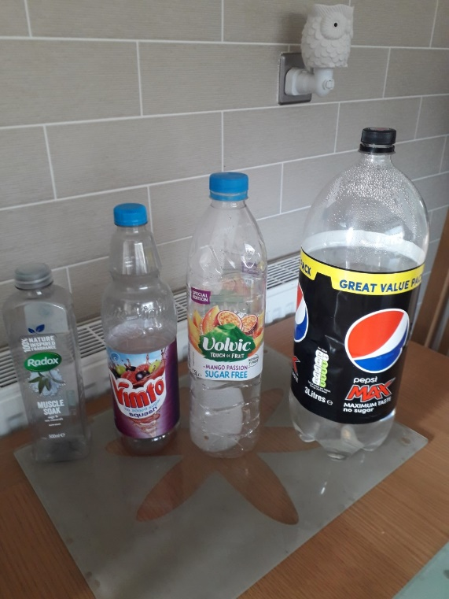
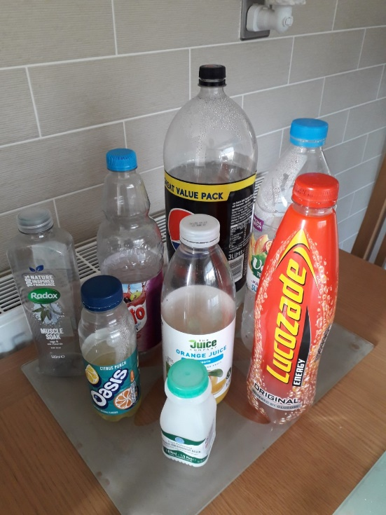

PAGE 2
Literacy
Our last day of poetry.
This year we have looked at lots of different types of poetry, e.g.
Rhyming poems, kennings, alphabet poems, alliteration poems, rap poems and acrostic poems .
- I would like you to write me a food poem in the style of one of the above poems. The choice is yours. I look forward to reading your poems. Poems are meant to be read aloud so we will also read them to each other when we are back in school.

AFTERNOON
ERIC – Reading time – choose a book to read by yourself.
- Welsh Helpwr Heddiw If you and your family feel confident enough have a little conversation in welsh using the language mats.
An app called ApGeiriaduron is a free app you can download that helps with unfamiliar welsh words too.
Welsh
- As our topic this term is food I would like you to design me a menu that we can use in a role play café when we are back in school.
It should be in welsh using welsh words and prices. It could be a pizza parlour or a sandwich shop.
You could either draw the pictures on paper or use clip art.
Include drinks, a main meal/ sandwiches/ pizzas etc and something for a pudding.

PAGE 3

Caffi Cwtch
Diodydd
Sudd oren 50c Llaeth siocled £1.20c
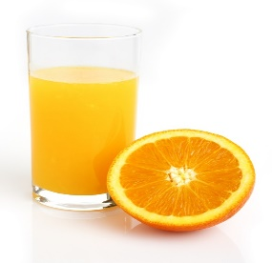

This Photo by Unknown Author is licensed under CC BY-SA

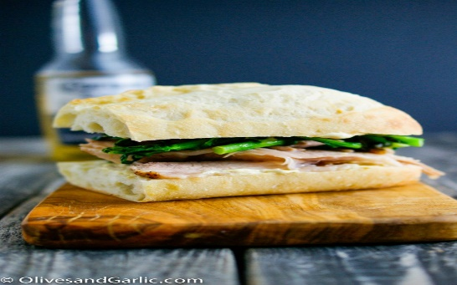
Brechdanau - £2.50c
This Photo by Unknown Author is licensed under CC BY
Ham , caws, Ham a chaws neu cyw iâr.

Pitsa caws - £6.10c

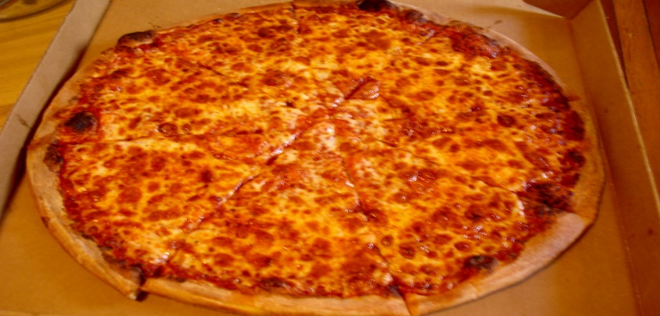

Pei afal efo cwstard neu hufen ia - £3.20c
Cacen siocled - £4.00c

PAGE 4
PSHE:Kindness
Favourite book.
- Can you tell me what your favourite book is and why?
Last week was World Book Day. There are lots of books and stories containing heroes and villains. Many fairytales have heroes or heroines who come through al kinds of adversities and end up living happily ever after. Heroes and heroines display good qualities of personal courage, caring for others and being good role models.
I’m sure you know the story Matilda by Roald Dahl. Matilda would definitely be a hero and Miss Trunchbull the villain.

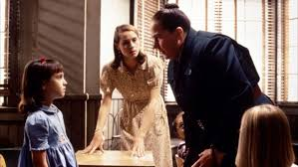

There has been lots of heroes during the past year such as Captain Tom.
- I wonder if you can think of any heroes in stories that show kindness?
You could draw a picture or find a picture online.

PAGE 5
Friday
Numeracy – warm up - practice times tables on BBC Supermovers , ict games or TT Rockstars.
Today, I would like you to have a go at an online capacity game – Capacity Countdown on ictgames.com. It starts off quite easy and then gets harder.

https://www.ictgames.com/mobilePage/capacity/index.html

Literacy/RE – The Easter Story
I wonder if you know the main points of the Christian festival of Easter. Who are the people? What are the days in the story?
Watch and listen to the video of the Easter Story – see my video.

There are several parts to the Easter Story
– Palm Sunday,
Maundy Thursday (The Last Supper), Good Friday and Easter Sunday.

- I would like you to make me a story map including the four days above.

AFTERNOON
- ERIC – Read a book of your choice.
- PE – This morning, you may have completed Joe Wickes Friday keep fit challenge.
I have attached another P.E. challenge on HWB and Dojo – a little challenge you might like to try.
HAVE A LOOK AT THE VIDEO ON GOOGLE CLASSROOM

Have fun and stay safe.
Mr Williams

