1dot 11.3.21 Fractions
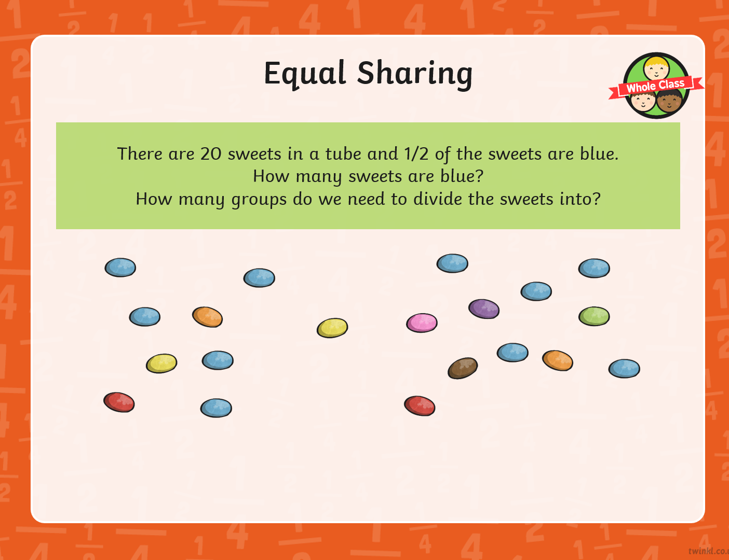
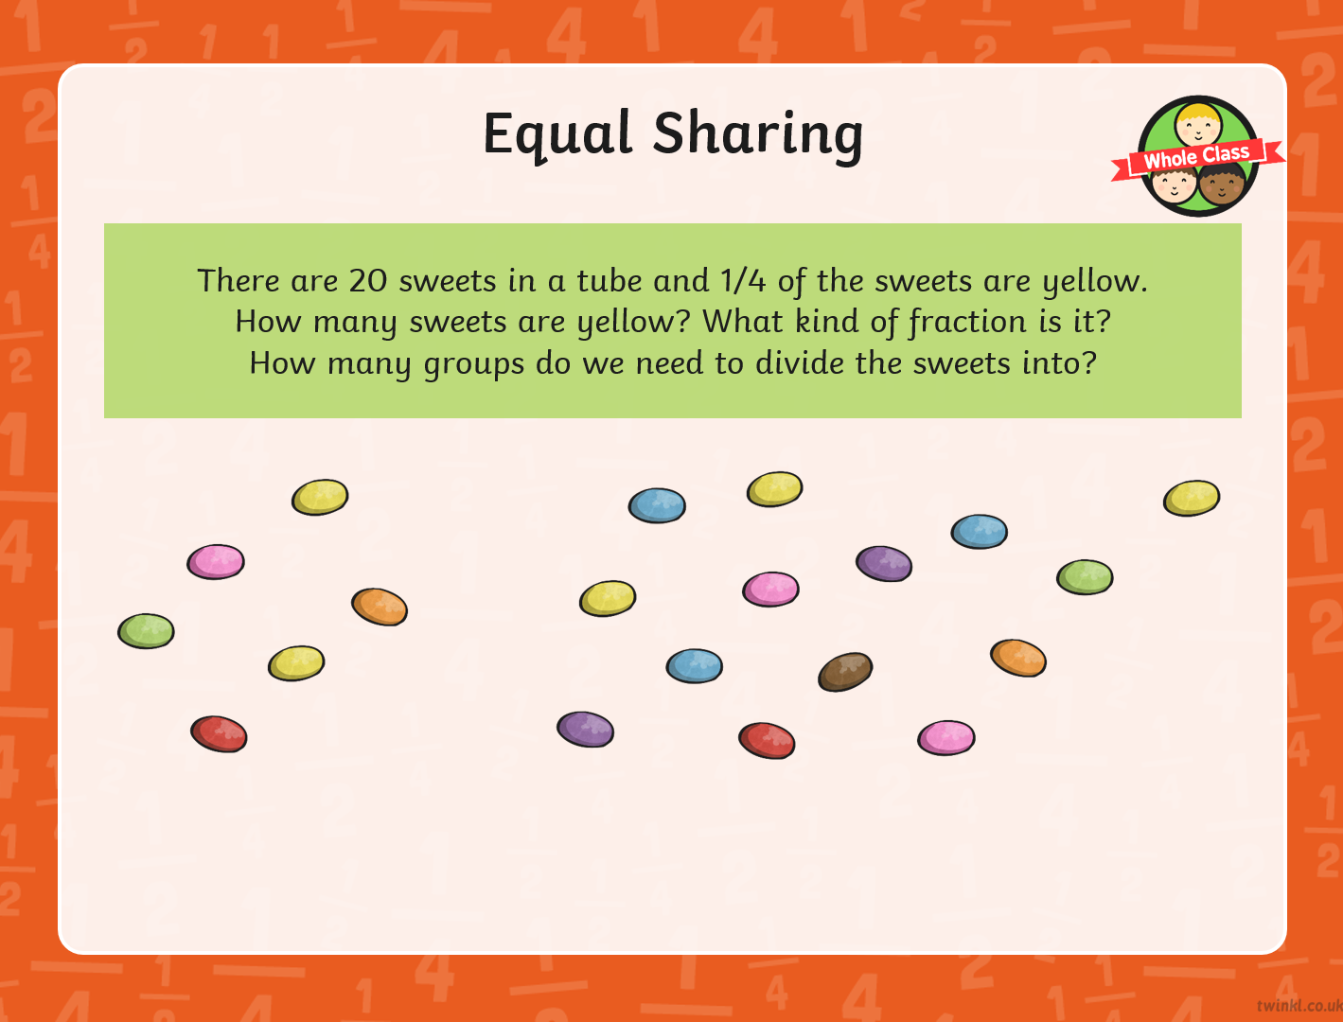
2dot 11.3.21 Fractions
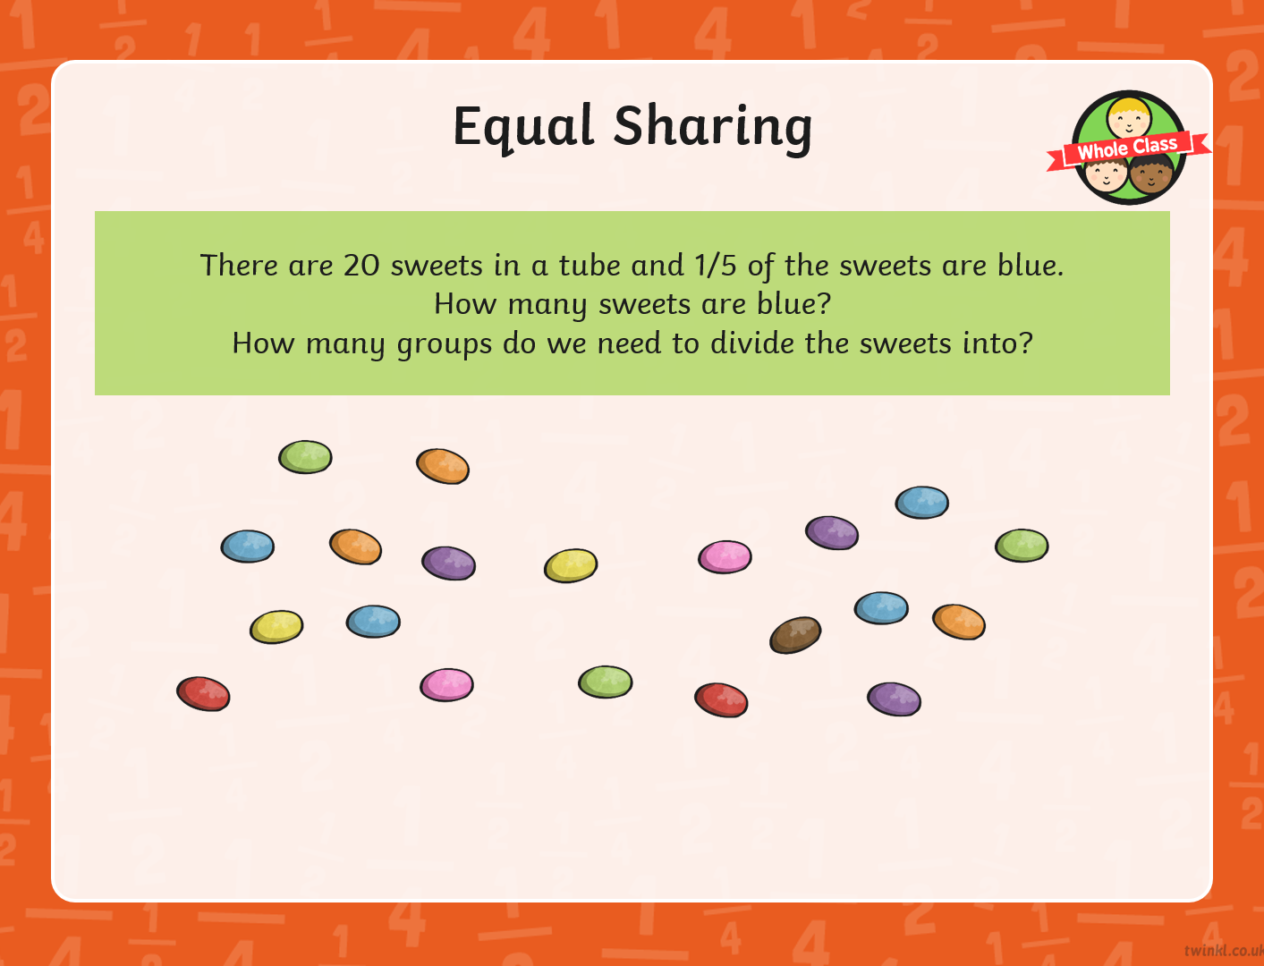
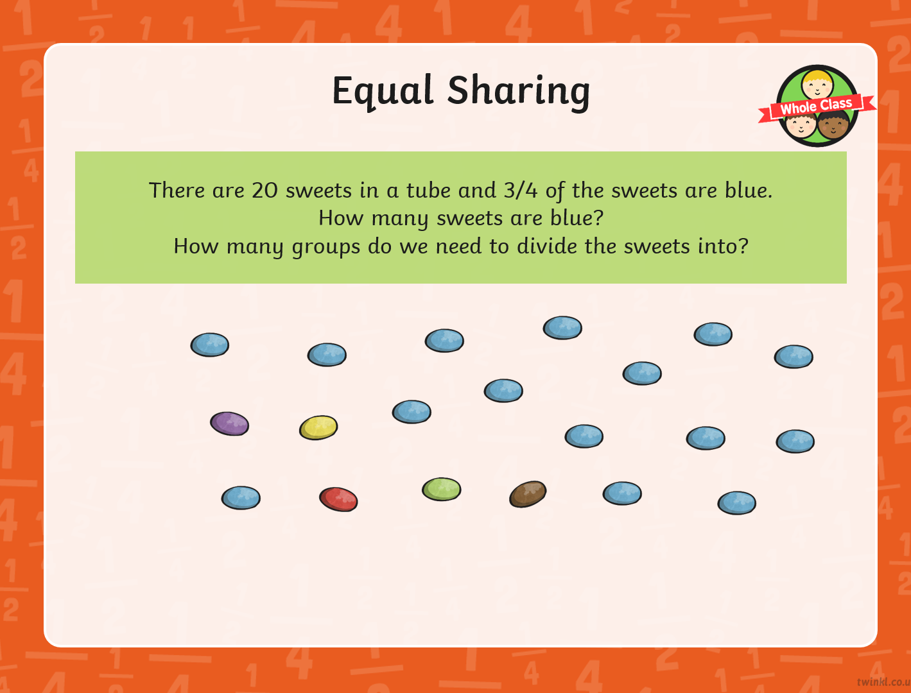
3dot 11.3.21 Fractions
You can draw a picture to help you work out the answers.
- There are 24 sweets in a tube. ¼ of the sweets are blue. How many are blue? How many groups do we need to divide the sweets into?

- There are 28 sweets in a tube. ¾ of the sweets are yellow. How many are yellow? How many groups do we need to divide the sweets into?

- There are 15 sweets in a tube. 1/5 of the sweets are green. How many are green? How many groups do we need to divide the sweets into?

- There are 20 sweets in a tube. 2/5 of the sweets are red. How many are red? How many groups do we need to divide the sweets into?

