PAGE 1
Year 4 Home Learning 2021 Week 8 – Thursday and Friday
Thursday
Numeracy – warm up - practice times tables on TT Rockstars or BBC Supermovers.
A little recap of mass, weight and weighing today with a Who Wants to be a millionaire maths weighing quiz. I will put the link on school website, dojo and HWB.
You can play along with me on a video or have a go by yourself.

Literacy – A Disgusting sandwich recipe – see my video.
The disgusting sandwich!
You may remember a story called The Disgusting Sandwich. I think I’d prefer a BLT or tuna mayonnaise. A bit of fun today. Let’s make a Year 4 poetry book of disgusting sandwich or soup recipes. Have a look at my poem and see of if you can make a disgusting recipe too. It hasn’t got to rhyme. Have fun 😊
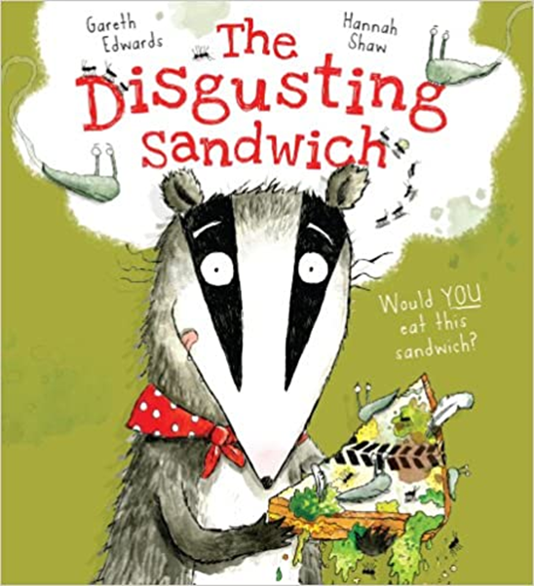
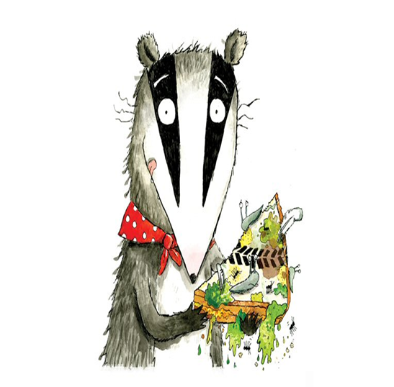
PAGE 2
The disgusting sandwich
By Mr Williams

I’d like to make you a sandwich, a disgusting sandwich
This is what you need
One eye of a slimy frog
Two hairs from a smelly dog
Three mothballs from tabby cats
Four grey gnats

Yuck!

How about a squeeze of a sour lemon
and a mouldy melon
A bit of salt and pepper
might make it taste a bit better

and voila – a disgusting sandwich.

I look forward to reading your disgusting sandwich or soup poem recipes …

PAGE 3
ERIC – Reading time – choose a book to read by yourself.
- Welsh Helpwr Heddiw If you and your family feel confident enough have a little conversation in welsh using the language mats.
An app called ApGeiriaduron is a free app you can download that helps with unfamiliar welsh words too.
Welsh
During half term it was pancake day. I wonder what toppings you had?
My favourite is the classic lemon and sugar. Ice cream is nice too.
I’d like you to ask your Mum or Dad, Nanna or Grandad or brother or sister what their favourite is. I wonder id you can remember how to ask the question – Do you like? or What do you like?
Then can you imagine you are in cafi crempog – Pancake café and ask for one.
e.g. Ga i crempg efo lemwn a siwgr. Ga i crempog efo hufen ia a mefus.
Please watch my video to help you.

PSHE/RE – Ash Wednesday/ Lent
The day after Pancake Day is Ash Wednesday and Lent whereby people give up something for 40 days until Easter.
What would you give up?
It should be something hard to give up. I would find it hard to give up chocolate

PAGE 4
Friday
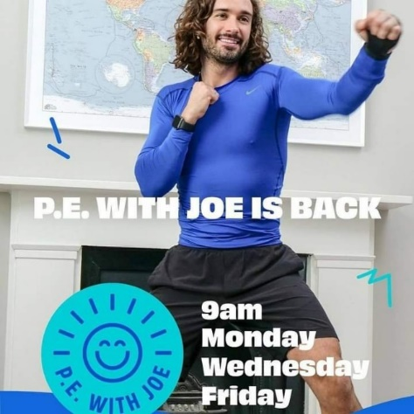
Morning – Joe Wicks at 9 if you’d like to join in.

Numeracy – warm up - practice times tables on BBC Supermovers , ict games or TT Rockstars.
We have learned that some objects are a lot heavier than others. For example a bag of sugar weighs 1kg and is heavier than a standard bag of pasta that weighs 500g.
If you had some balancing scales you would see that the sugar would sit on the table and the pasta would be in the air as the sugar is heavier. If I sat on a see saw and a hippo sat on it I would definitely be in the air

For a bit of fun today I would like you to think of some objects you could put in bucket scales of a see saw and draw or use clip art for me which is lighter or heavier and then yourself and some animals on a see saw.
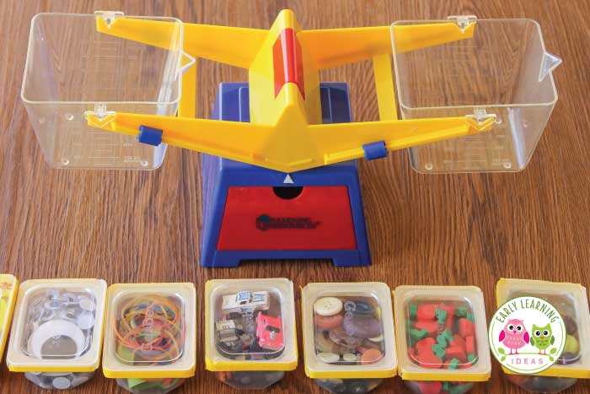

PAGE 5
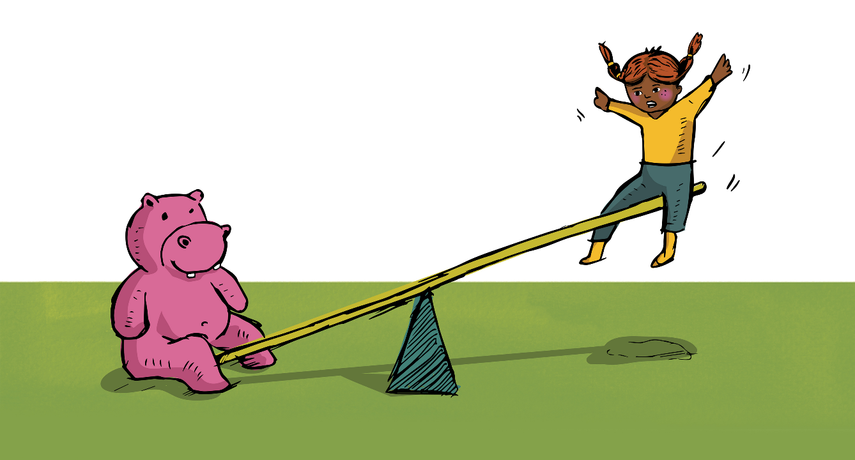

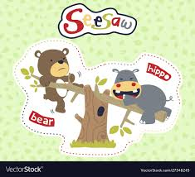

PAGE 6
Literacy – Editing a poem in welsh.
A big part of poetry is editing poetry. Changing and adapting lines and words. Below is an example of a welsh poem we have been looking at for the school eisteddfod – Parti.. See if you can edit the poem to make your own welsh food poem. It is easier to keep the parts in yellow and change the rest by choosing new words/phrases.

Y Frechdan ych a fi
Brechdanau, brechdanau
Dw i’n dwli ar brechdanau ych a fi
Brechdanau, brechdanau
Rhowch mwy o frechdanau i mi.

Un llygad ellifant
Dau dant siarc
Tri lemwn sur
Pedwar coeasu broga
Dw i’n dal yn llwyglyd...

Wyth banana du,
Dw i’n dechrau chwysu!
Naw sgwp o fwstard
Deg...
BLYYYYCH!
O na, dw i wedi chwydu!...

PAGE 7
AFTERNOON
- ERIC – Read a book of your choice.
- PE – This morning, you may have completed Joe Wickes Friday keep fit challenge.
I have attached another P.E. challenge on HWB and Dojo – a little challenge you might like to try.
HAVE A LOOK AT THE VIDEO ON GOOGLE CLASSROOM
PSHE –
Things are starting to look more positive and we will back together in class soon!
I can’t wait to visit the beach, go for a swim, watch a film at the cinema and a show at the theatre etc.
Boris Johnson announced a roap map for England last week and Wales have said things will start to reopen soon.
Maps help us when we are lost to find somewhere and also to help with writing a story etc.
Can you draw a mind map of all the things you cant wait to do again. Perhaps in order of what you like the most or what’s most important to you…
It could be a picture of you in the corner with a thought bubble.

Have fun and stay safe.
Mr Williams

