PAGE 1
Year 4 Home Learning 2021 Week 5 – Thursday and Friday
Thursday
Numeracy – warm up - practice times tables on BBC Supermovers.
6 Nations Maths
In rugby union you score points in different ways e.g.
A try = 5 points
A conversion ( A kick over the posts after a try) = 2 points
A penalty = 3 points
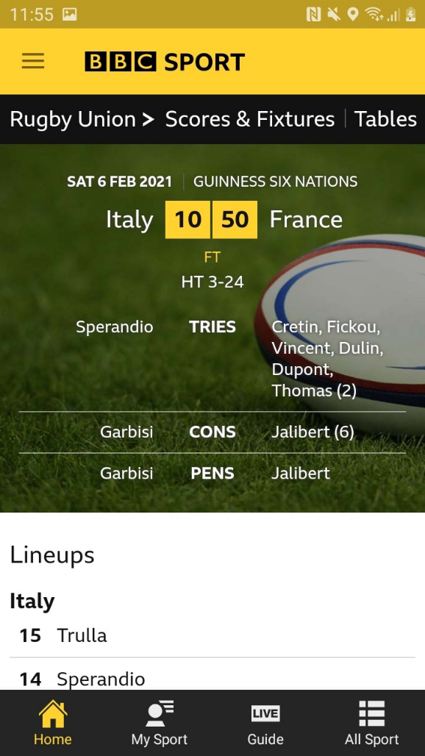
A drop goal = 3 points

Have a look at the picture on the left from the first game from the opening weekend between Italy and France.

Italy 10 France 50
Italy got their points from a try and a conversion and a penalty.
5 + 2 + 3 = 10
France had 7 tries, 6 conversions and 1 penalty.
7 x 5 = 35
6 x 2 = 12
1 x 3 = 3

PAGE 2
TASK
These are the scores from the other two games. I wonder how they could have scored the points. Can you come up with some possibilities.

England 6 Scotland 11
Wales 21 Ireland 16

Literacy – Acrostic poems.
I would like you to write an acrostic poem or two about a welsh emblem or icon such as : daffodil, dragon, leek, Tom Jones or a place.
Remember an acrostic poem uses each letter of the subject to make a sentence e.g.
Leeks are vegetables,
Every year we wear them on our jumpers,
Every harvest we pick them,
Keep eating your five a day.

P.M.
ERIC – Read a book of your choice.
Welsh – you may like to practice the two Eisteddfod poems. Parti a Pizza.
See my video from week beginning 08/02/21

Food tasting activity – see Miss Jones’ video.

PAGE 3
Friday
- Numeracy – Symmetry of welsh emblems. See video and sheet attached.
- Literacy – Story of St. David.
Read the powerpoints about St.Davids Day and our patron saint of Wales.
I’d like you to share with me some information and images about St.David, the traditions of St. Davids Day and what it means to be welsh.
It’s up to you how you present your information/ research. It could be a powerpoint, a fact sheet, a poster or quiz.

PM –
ERIC – read a book of your choice.
- PE: Dance – see the folk dance video.
- Class Assembly – watch the video about Pancake Day/ Shrove Tuesday.

I HAVE ALSO SHARED SOME WELSH CRAFTS/ACTIVITIES YOU MAY LIKE TO HAVE A GO AT IN THE AFTERNOONS.

Have fun and stay safe.
Mr Williams

