PAGE 1
Year 4 Home Learning 2021 Week 5 – Thursday and Friday
Thursday
Numeracy – warm up - practice times tables on BBC Supermovers.
Reading scales and writing the amount shown.
Last week I shared a guide on mass and weight.
Please look at today’s video showing scales and weight.
You may have had a go at mostly postie on ictgames.com last week which I hope helped.
TASK
- I have attached some sheets with scales on. Please answer on paper and send photo or reply on google classroom with the weight the scales show.
1 dot – page 1 in kg or g
2 dot – page 2 in kg or g
3 dot – page 2 in kg and g
Literacy – Rap poems
So far we have looked at some different types of poetry – rhyming poems, list poems, alphabet poems and kennings. We have looked at features such as: rhyming words, similes and metaphors, alliteration, onomatopea and repetition.
Today we are going to look at some rap poems.
Rap poems are great to read/perform aloud as they have a regular beat. They usually have a line or verse that is repeated and also rhyming words.
TASK
Today is a reading activity to spot the above features.
- Please read and enjoy the following poems – Fuss Fuss Fuss! or The Goldilocks Rap, Sugarcake bubble, Brian’s Picnic.

- Which is your favourite and why?

- With a highlighter or coloured pens (if you have some) you could try and spot the parts that are repeated and spot the rhyming words used.

PAGE 2
ERIC – Reading time – choose a book to read by yourself.
- Welsh Helpwr Heddiw If you and your family feel confident enough have a little conversation in welsh using the language mats.
Welsh

Today you have two food poems to read, translate and perform.
I will help you by reading them to you. There is a box at the bottom of the poems with some tricky words. I’d like you to see if you can translate them and practice saying them. Unfortunately this year our school Eisteddfod will have to be different to usual but we will still be having the usual competitions. The poem ‘parti’ is a favourite that we usually perform in Year 4 most years but I thought we would have a look at another one about pizza as well.

An app called ApGeiriaduron is a free app you can download that helps with unfamiliar welsh words too.
Please watch my video to help you.

PSHE/RE – Tomorrow is Chinese New Year – I’d like you to look at the powerpoint.
You could make me a poster or powerpoint about Chinese New Year and perhaps carry out some more research of your own. You don’t need to do it all this afternoon. You could do it today and tomorrow.

PAGE 3
Friday
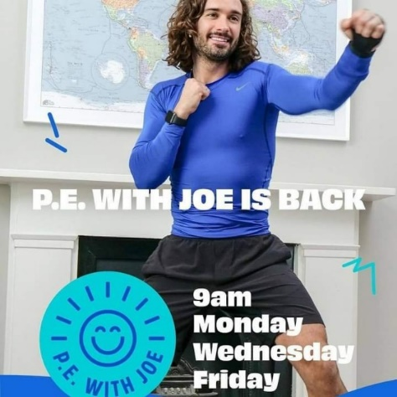
Morning – Joe Wicks at 9 if you’d like to join in.

Numeracy – warm up - practice times tables on BBC Supermovers , ict games or TT Rockstars.
Converting between g and kg.
We learned that a bag of sugar is 1kg. We could also say 1000g as 1kg = 1000g.
A bag of pasta was 500g. We could also say 0.5kg or ½ kg.
Remembering our decimals really helps e.g. 0.5 = ½ 0.75 = ¾ 0.25 = ¼
TASK
I’d like you to try to convert between g and kg. Please see the attached sheets.
Literacy – Rap poems
Yesterday you saw some good examples of rap poems. Today I’d like you to read the poem – Healthy Food Rap.

PAGE 4
Healthy Food Rap
You are what you eat,
You eat what you are,
If you eat the right stuff then you’ll go far

Apples, oranges, bananas and pears,
Are packed with vitamins for body repair cos…..

You are what you eat,
You eat what you are,
If you eat the right stuff then you’ll go far

Meat, is neat
Packed with protein and iron
Builds up your muscles
Makes you strong like a lion cos

You are what you eat,
You eat what you are,
If you eat the right stuff then you’ll go far

Milk, yoghurt and cheese is yum,
Builds up your bones with calcium cos

You are what you eat,
You eat what you are,
If you eat the right stuff then you’ll go far
PAGE 5
Cakes, and sweets,
Are nice for a treat
Don’t eat too much or
You’ll feel the heat cos..

You are what you eat,
You eat what you are,
If you eat the right stuff then you’ll go far

Rice, bread and pasta too,
Are packed with carbs and
Energy for you cos…

You are what you eat,
You eat what you are,
If you eat the right stuff then you’ll go far

TASK
- Can you add another verse?
- Could you adapt and edit the poem Brian’s picnic. Eating cakes and sweets and cakes is fine in moderation, but not all the time.
The poet repeated the line – I WANT A DOUGHNUT!
I wonder if you could make Brian’s picnic more healthy by changing the repeating line and also some of the food he has in his picnic. If you keep the rhyme even better!

PAGE 6
AFTERNOON
- ERIC – Read a book of your choice.
- PE – This morning, you may have completed Joe Wickes Friday keep fit challenge.
I have attached another P.E. challenge on HWB and Dojo – a little challenge you might like to try.
HAVE A LOOK AT THE VIDEO ON GOOGLE CLASSROOM
PSHE – DREAMS
Last week we spoke about dreams and I loved reading yours. Unfortunately some times things happen that make getting our dreams difficult. What could we do though to deal with our disappointment? Maybe you can think of a time when a dream of yours didn’t happen. You don’t have to say if you don’t want to. What did you do to feel better?

My dreams was to travel to Australia last year and see friends who live there in the second week. Unfortunately it didn’t happened and it probably wont happen this summer either. However I will rebook for 2022 and plan more fun things to do when I can go.
Below are some things that caused disappointment for some children. I wonder what they could do?
- Emma and Oliver are promised a puppy which is then not allowed in the flats where they live.

- Tom thought he would be selected for the school football team but finds out he is only a reserve.

- The swimming pool party is cancelled at the last minute.

- PSHE/RE – Next week is Shrove Tuesday or also known as Pancake Day. Please have a look at the little powerpoint. We will learn more about Shrove Tuesday and Ash Wednesday after Half Term.

Have fun and stay safe.
Mr Williams

