Year 1 22/01/2021
PE
Hi everyone hope you all keeping safe.
This week we are doing Boogie Beebies - Hey Monkey
https://www.bbc.co.uk/programmes/p01z03gr
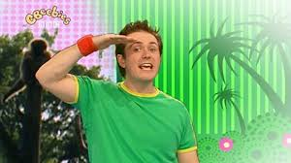

PSHE
Things that make you happy!
Have a chat to a grown up about what make you feel happy and what makes them feel happy
This Photo by Unknown Author is licensed under CC BY
Then fill in the picture on the link or draw your own to tell me What makes you happy.
https://content.twinkl.co.uk/resource/5c/a3/t-tp-5194-things-that-make-me-happy-activity-sheet.pdf?__token__=exp=1610626027~acl=%2Fresource%2F5c%2Fa3%2Ft-tp-5194-things-that-make-me-happy-activity-sheet.pdf%2A~hmac=e9b512654ff753769c57b8d9d0ce73c3ed7e2fa97a4fffe546fb56d02b3ea06f
