Year 4 Home Learning 2021 Week 3 – Thursday and Friday
Thursday
Numeracy – warm up - practice times tables on BBC Supermovers.
Maths games online – ictgames.com for those that finish work or want some extra work.
https://www.bbc.co.uk/teach/supermovers/ks2-collection/zr4ky9q
- Please read the bar graph powerpoint to remind yourself how to construct a bar graph.
- Today you can discover what the most popular fruit is in Year 4.
- I put a question on HWB/ Google classroom. You should have picked one fruit – either apple, banana, orange or strawberry and wrote your name on the classroom wall.
O.S.C. Our success criteria. What we need to include.
1.Make a tally first with the number of who liked each fruit.
2.Then remember to write a title for your graph.
3. Draw your 2 axis with a ruler. A vertical and horizontal line.
Fruit along the bottom (horizontal) and number of children going up (vertical)
4. Now draw your bars. Remembering to leave a gap between your bars.
You may wish to colour them in.
Literacy
Poetry – Last week we looked at poetry on Thursday and Friday and you also looked at similes with Mrs Brown.
I liked your simile sentences!
Here’s a couple of mine.
The cherries were as red as Rudolph’s nose.
Santa’s belly wobbled like Jelly.
The ice cream made my tongue as cold as Frosty the snowman’s toes.

Today we are going to have a recap of similes before looking at metaphors tomorrow.
- Have a look at the similes and metaphors guide attached. Read slides 1 – 4 today. Can you think of simile sentences for the 5 images on slide 4 ?
- You may wish to write some more food simile sentences.

Afternoon
ERIC – Reading time – choose a book to read by yourself.
Welsh Helpwr Heddiw – If you and your family feel confident enough have a little conversation in welsh using the language mats. Don’t worry if you are unable to.
Last week in Welsh we looked at writing sentences about ourself.
- Today I would like you to read a profile about Marcus Rashford. I wonder how much you understand.
Here is mine wrote in a similar way to the example of Marcus Rashford.
Mr Williams ydw i. Dw i bron 40 oed a dwi’n byw yn Wrecsam. Mae gen i un brawd o’r enw Matthew. Dw i’n hoffi bwyta lasagne ond dwi ddim yn hoffi cacen moron. Dw i’n mwynhau rygbi ond dwi ddim yn hoffi criced. Mae criced yn sbwriel. Ddiflas iawn!
• Why not have a go at writing a paragraph using the template.

You may also like to do your daily mile bingo challenge or do some cosmic kids yoga.

Friday
Morning
Numeracy – warm up - practice times tables on BBC Supermovers and games online – ictgames.com
https://www.bbc.co.uk/teach/supermovers/ks2-collection/zr4ky9q
Yesterday, you learnt how to construct a bar graph. Well done.
Today there is a bar graph with questions to answer.
Literacy – Today we are going to look at metaphors. Metaphors are different to similes. They don’t use like or as a … Instead they say something is something else.
e.g.
The curry was fire in my mouth. (metaphor)
My sister had candy floss hair. (metaphor)
- Read the simile and metaphor guide. Read slides 5 -8.
- Slide 4, can you write some simile sentences for the 5 images?
- Perhaps you can think of some food metaphors like mine.
- Also have a look at the What am I? powerpoint.
There are 4 boxes with clues in using similes and metaphors. Can you guess what they are describing?
AFTERNOON
- ERIC – Read a book of your choice.
- PE – This morning, you may have completed Joe Wickes Friday keep fit challenge.
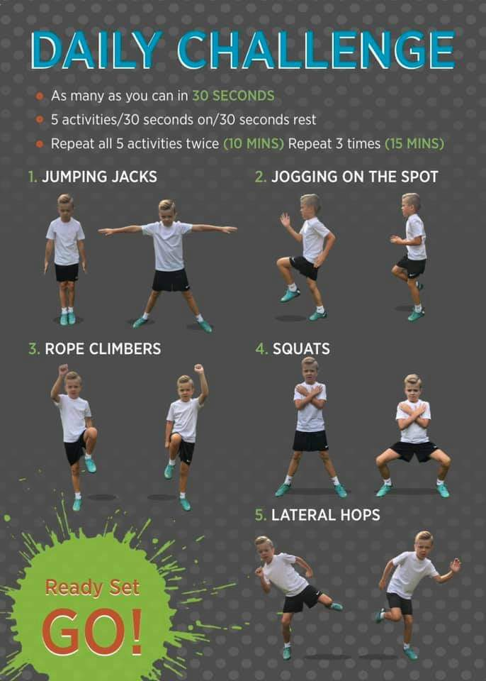
Here is another P.E. challenge for today. Do what you are comfortable with. You haven’t got to do it 3 times!

PSHE – Well being box.
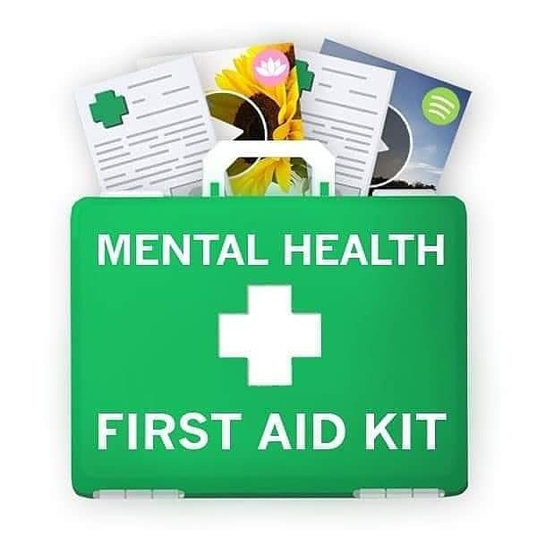

Your well being is so important this year. As well as keeping your body fit you need to look after your well being and try not to worry too much. It is important to rest, relax and switch off from school too. We spoke last year in circletime about how you relax. If you had a box of things that helped you stay calm, cheer yourself up and be positive what would you include.
You can write a list or make a poster.
Here’s mine….

Mr Williams’ well being box
A pair of trainers.
My ipod
Some books
A jigsaw

Have fun and stay safe.
Mr Williams

