PAGE 1
Year 4 Home Learning 2021 Week 4 – Thursday and Friday
Thursday
Numeracy – warm up - practice times tables on BBC Supermovers.
An introduction to mass and weight.
- Please read the powerpoint on weight and mass attached to class dojo/google classroom.
- A bag of sugar weighs 1kg or 1000g.
Hold your bag of sugar to see what 1kg feels like.
- Can you find some other items in your kitchen that you think are both lighter and heavier. Without cheating, have a look at the label/packet on the box to see if you were right. You may not find something heavier than 1kg with a label on but don’t worry. It could be an object instead. You may have some scales in your house you could use over the next couple of weeks.
- I have taken a photo of a collection of objects – a bag of sugar, a bag of pasta, a bag of rice, a bowl of fruit, a bag of crisps and a box of chocolates.
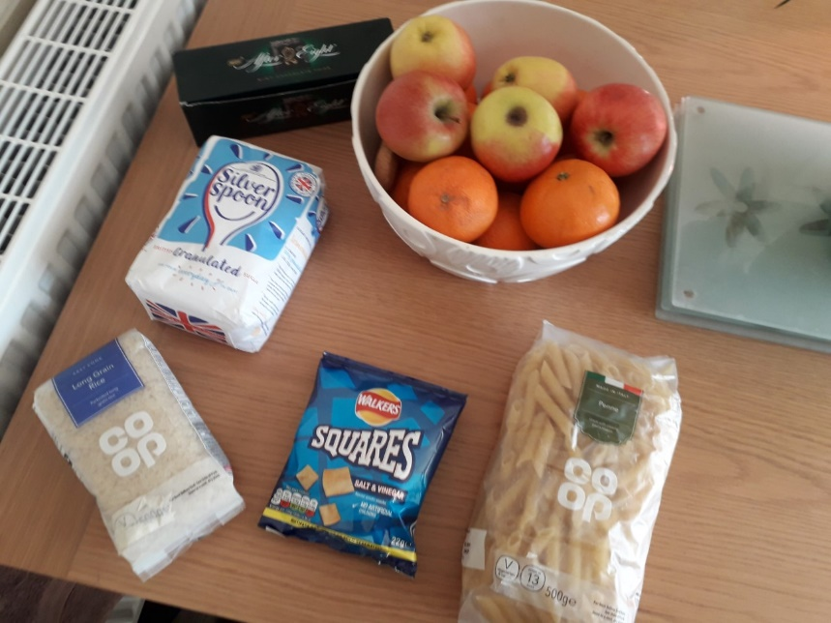

- Can you put them in order from lightest to heaviest?
- What do you think each of them weigh? Just estimate ( guess)
I’ll give you the answers this afternoon/tomorrow.
- I will attach a sheet of objects with 3 options of what each one weighs. Choose which one you think each is. Page1 – 1 and 2 dot. 3 dot can challenge themselves with estimating the mass.

PAGE 2
Literacy – rhyme and onomatopea.
- Rhyme challenge. You have seen that some poems rhyme.
Sometimes the end of each line rhymes or the 1st and 3rd line in a verse will rhyme.
The words fun and run rhyme. Likewise yellow and mellow rhyme.
Can you spot the pairs of rhyming words on the sheet attached?
- Onomatopea is the sounds we hear e.g. sausages sizzle, crispbreads crack.
You saw some examples in some poems we read, especially ‘Sound Good’ poem.
Can you write some examples about food and other things.
Eg. Popping pocorn.
Whizzing fireworks.
Afternoon
ERIC – Reading time – choose a book to read by yourself.
Welsh Helpwr Heddiw –
Please watch my video to help you.
- If you and your family feel confident enough have a little conversation in welsh using the language mats. Don’t worry if you are unable to.
- Last week you wrote a personal profile like Marcus Rashford. I have attached a personal id card about Marcus Rashford.
Can you write one about yourself and also about a cartoon character or a famous person from history or celebrity. Maybe Bart Simpson. You can make it up if you don’t have all the information. When we are back in school we will use them to play guessing games.
Keeping active - You may also like to do your daily mile bingo challenge or do some cosmic kids yoga.

PAGE 3
Friday
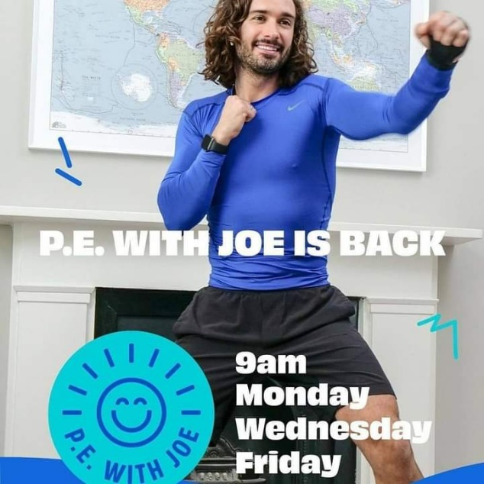
Morning – Joe Wicks at 9 if you’d like to join in.

Numeracy – warm up - practice times tables on BBC Supermovers , ict games or TT Rockstars.
- I would like you today to order the weight of some objects.
I have attached a sheet. See if you can order them from lightest to heaviest.
Take a photo of the pictures once cut out or drawn/ written out and send it to me on dojo/ HWB.
Literacy –
I’ll explain kennings in a video for you. Today we are going to learn about kennings. A type of poem I haven’t shared with you yet. They are simple poems that only have two words on each line. They make the reader guess what the object or person or animal is. They are fun to write. They usually include a noun and an adjective (or sometimes a verb).
Remember a noun is an object, an adjective is a describing word and a verb is a doing word. In a kenning you don’t reveal the subject until then end.
e.g. Tail wager,
Bone muncher,
Cat hater.
Mud lover
I am a….. dog
PAGE 4
A couple of years ago one pupil called Levi in my class wrote a poem about me.

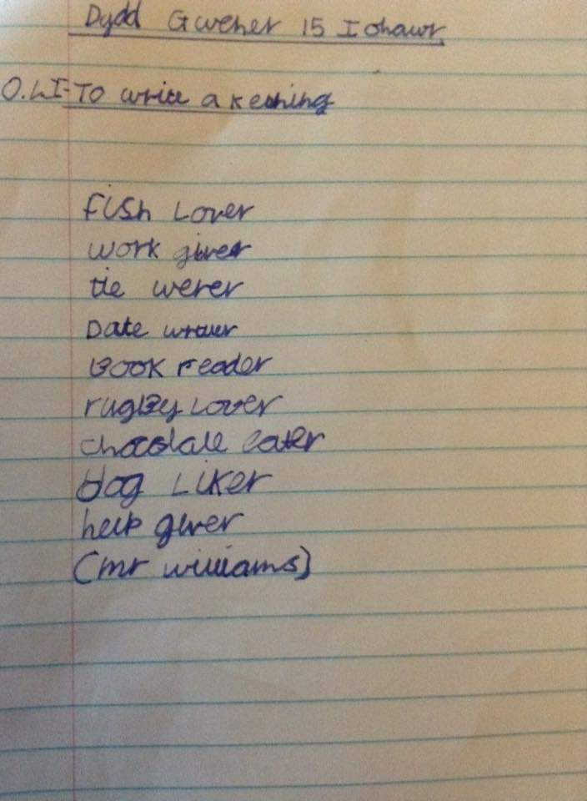

Fish lover
Work giver
Tie wearer
Date writer
Book reader
Rugby lover
Chocolate lover
Dog liker
Help giver

I am …Mr Williams

Read the kenning powerpoint and write me some examples.

PAGE 5
AFTERNOON
- ERIC – Read a book of your choice.
- PE – This morning, you may have completed Joe Wickes Friday keep fit challenge.
I have attached another P.E. challenge on HWB and Dojo – a throwing aim challenge you might like to have a go at.
HAVE A LOOK AT THE VIDEO ON GOOGLE CLASSROOM
PSHE – What are you proud of during this past 12 months?...
This past year has been so tough for all of us in different ways!
I am sure though that you have been proud of something that you have done. You all have so many talents. I know Evan is fantastic at riding his motorbike. I want his autograph and hope he remembers his teacher There are also some fantastic footballers in our class as well as budding artists and writers etc. You may have been proud of improving your reading, spelling, being able to tie your laces, baking etc.

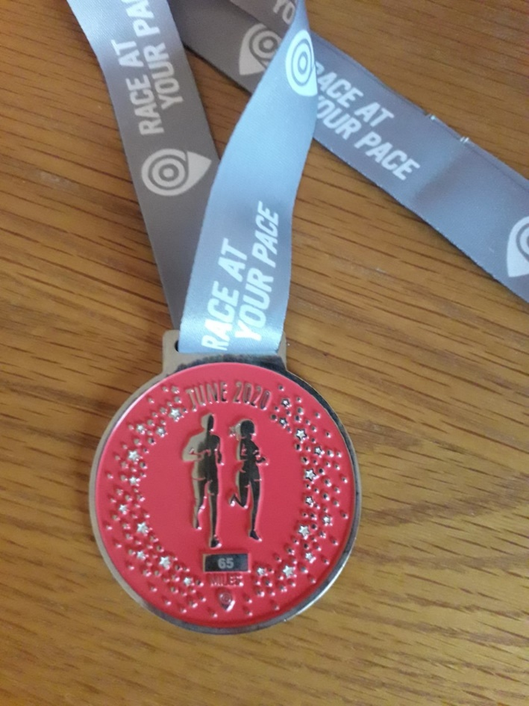

PAGE 6
I’m proud of running 65 miles over the month of June last year. My challenge/ goal this year is to run a marathon in October. To do this I am going to have to run often and run further than I have before. I will run with friends who run when safe to do so, eat healthy and do lots of stretches. I hope lots of you will run with me at lunchtimes soon I look forward to hearing about you.

Can you tell me:
- What are you most proud of since March last year?

- What is your challenge/goal for this year?

- What are the steps needed to reach your goal?

You can include photos and pictures if you wish.

Have fun and stay safe.
Mr Williams

