Reception 18th Jan 2021
PE
You had a special visitor in your class last week a lovely bird called a Robin with a beautiful red breast.
Listen to the EYFS Playtime programme to find out how a robin moves and listen to the story.
Remember to listen carefully and follow the instructions
https://www.bbc.co.uk/teach/school-radio/eyfs-playtime-robin/z7fq92p
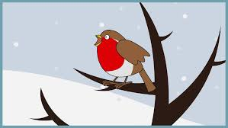

Music
Poor Robin can you learn the poem below and add your own actions to it.
