Year 4 Home Learning 2021 Week 2 – Thursday and Friday
Hi Year 4, thank you for all the work you did last week. You did so well! As usual it is up to you how you send the work. Printed off from school and send a photo on class dojo message or post in class dojo portfolio. Or on Google Classroom or pop it in your work book and bring back to school.
Thursday
Numeracy – warm up - practice times tables on BBC Supermovers.
Maths games online – ictgames.com for those that finish work or want some extra work.
https://www.bbc.co.uk/teach/supermovers/ks2-collection/zr4ky9q
- Please read the sorting shapes carrol diagram powerpoint. They are similar to venn diagrams helping us to sort out objects and information. Slide 6 will ask you to make up headings to sort out the shapes.
Literacy
Today we are going to start a new genre in literacy – poetry.
- Firstly I’d like you to think:
- What do you think poetry/ a poem is?

- What sort of poems can you think of? E.g. acrostic.

- What sort of features do you think you will see in poems? e.g. rhyming words.

Don’t worry if you haven’t got many ideas as we will be looking at a powerpoint and then reading some poems.
2. Now have a look at the poetry powerpoint attached on class dojo or Google Classroom. It will give you lots of information about poetry.
Today, just look at slides 1 – 6. Slide 6 tells you about features of a poem.

3. Lastly, I’d like you to read some examples of food poetry.
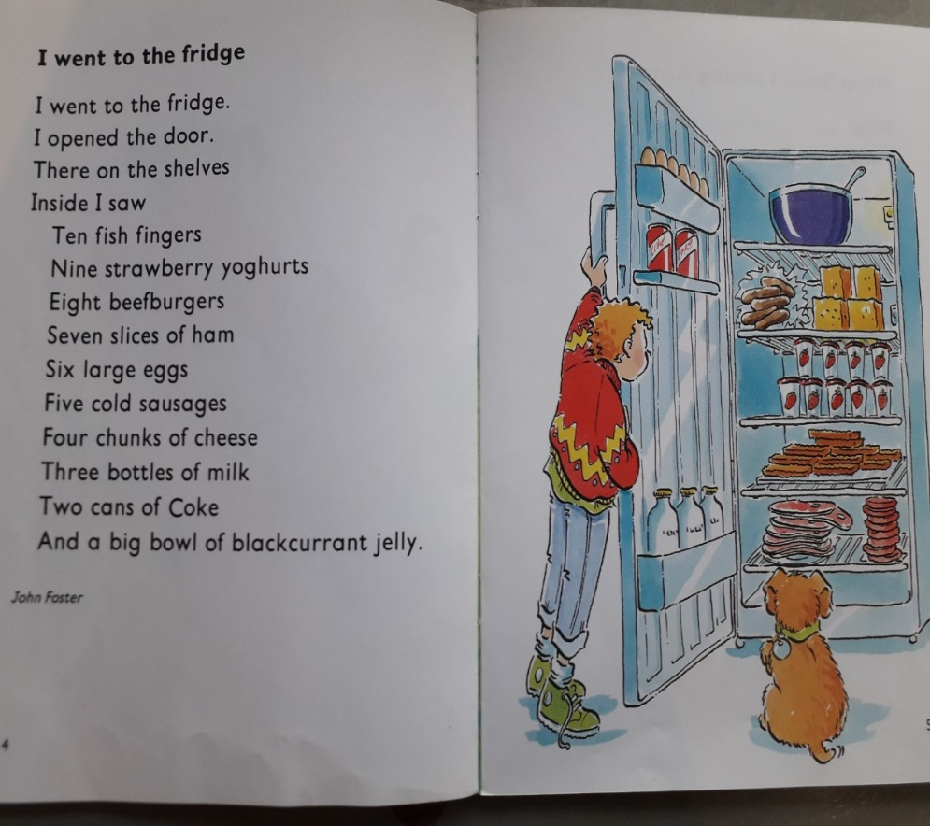

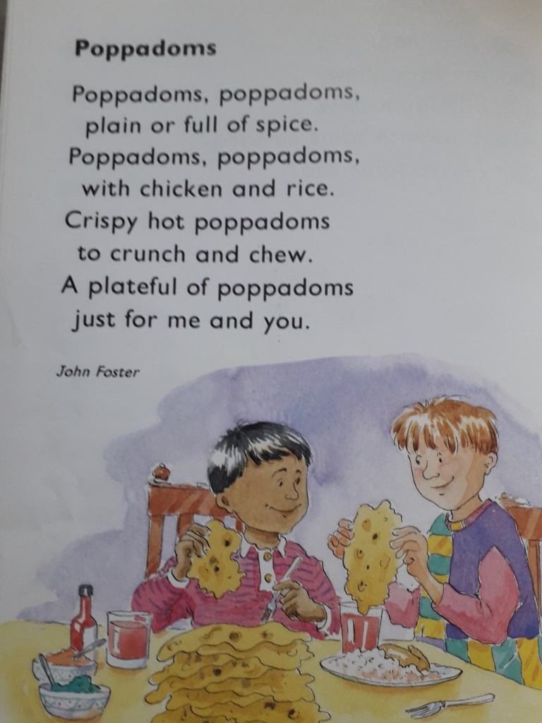

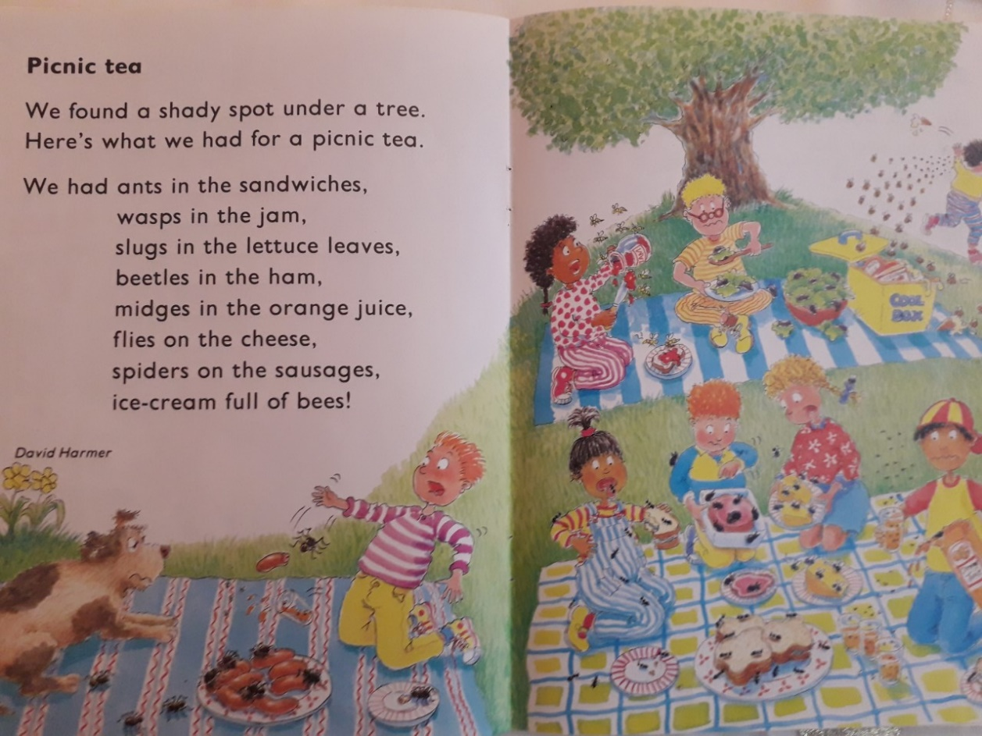

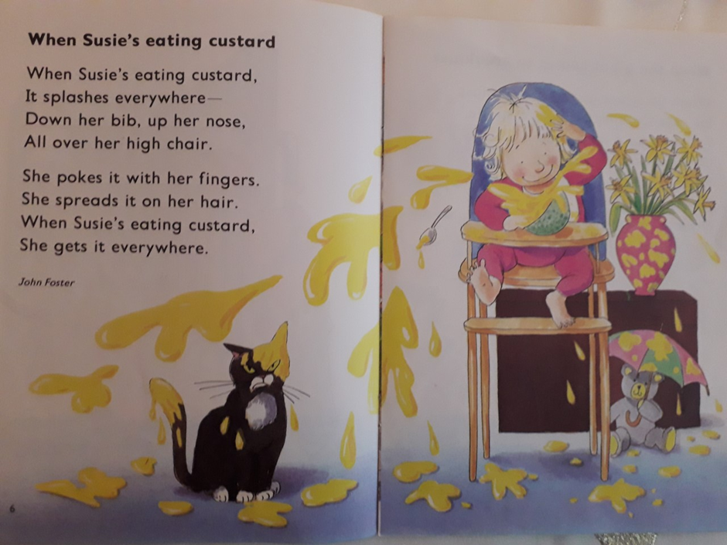

Afternoon
ERIC – Reading time – choose a book to read by yourself. You may like to do the daily mile bingo challenge.
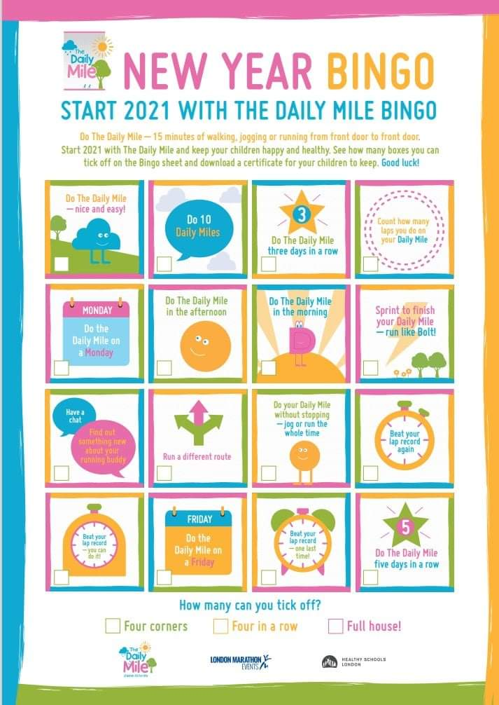
PSHE – Finding a bit of positivity and joy in tough times.
You may have seen on TV recently that Mostyn and his goat friends have been back down in Llandudno off the Great Orme as it has been so quiet again during another lockdown. It brought me joy and made me smile last year. I used to visit Llandudno a lot when my Grandparents lived in Prestatyn and sometimes saw the goats.
Something that brings me joy on my running route is seeing the wooden bear in Borras. It makes me smile when I’ve ran up a big hill.
Today’s PSHE task is to think what brings you joy/ makes you happy.
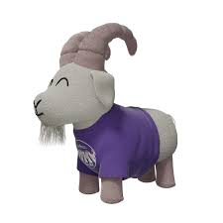
You can either take a photo and send it me with a caption or you could make a poster of several things that bring you joy. It could be a poster including a picture of TY Mawr, Dinas Bran, Wrexham Football Stadium etc.
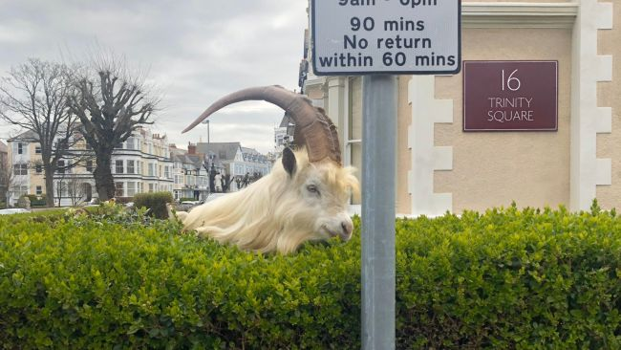

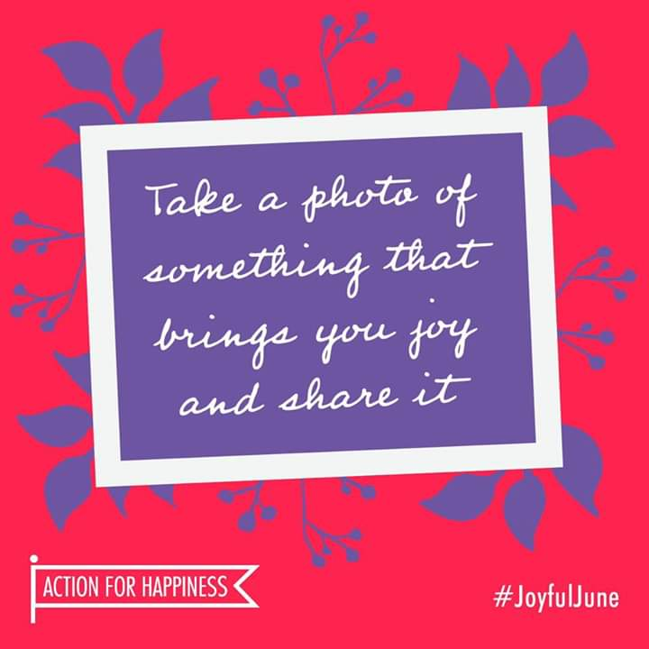

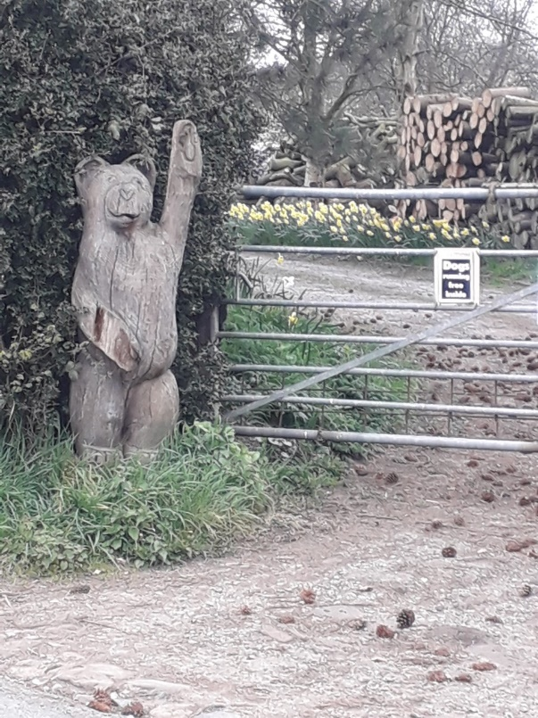

Friday
Morning
9 – 9.20 am – You may like to do Joe Wickes morning activity. If you don’t do it at 9am it is recorded and available anytime suitable on his youtube channel.
Numeracy – warm up - practice times tables on BBC Supermovers.
https://www.bbc.co.uk/teach/supermovers/ks2-collection/zr4ky9q
- Yesterday, you learnt what a carrol diagram is. Today can you solve the pirate carrol diagram. Maybe you can make up some of your own using the blank template.
10.05 – 10.15 am – You may like to watch BBC Bitesize on CBBC Channel or online.
Today’s celebrity supply teacher is Heston Blumenthal with Food Science as the topic.
Literacy – Yesterday you wrote down what you know about poetry, read some poems and learnt about features of poetry. Here are some more poems to read. You should spot some different features in these poems.
You will see that a poem doesn’t always have to rhyme and there are lots of different features. Poems may only have one or two of the features you just read about in the powerpoint. Poems can be very different. They are meant to be read aloud and are just as creative as stories. I hope you enjoy reading them.
Today I would like you to do two things,
- Tell me which is your favourite poem and why?

- Can you make notes on the sheets of paper/ poems telling me what features you can find. You can use a pen or pencils and a a highlighter. You could make a key e.g. yellow = rhyming words.
Can you find examples of – rhyming words, repetition, alliteration, onomatopea.
What sort of poems are they? A list poem, a rhyming poem, a rap poem?

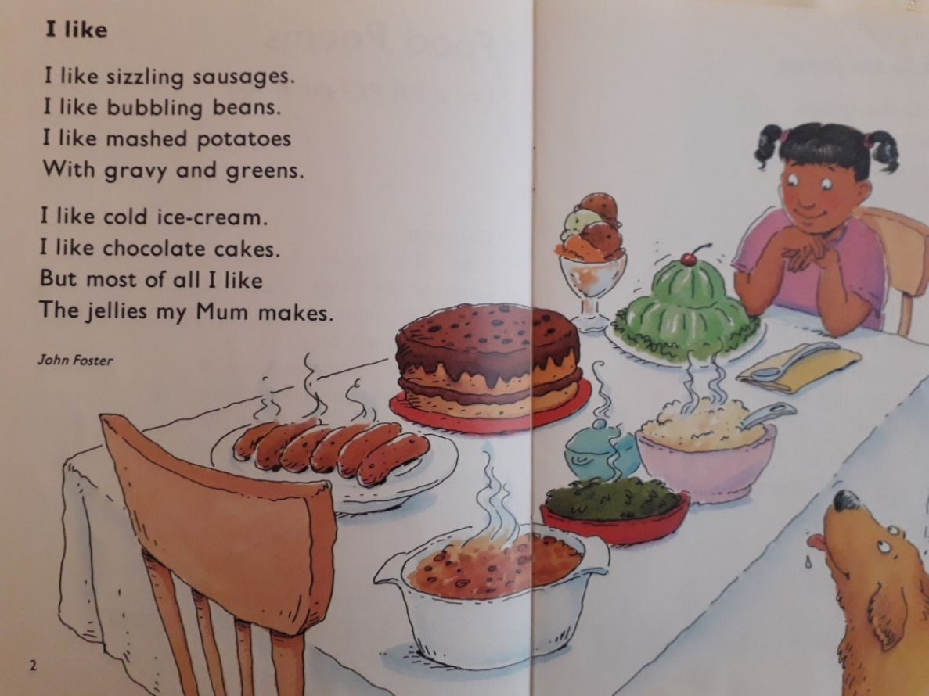
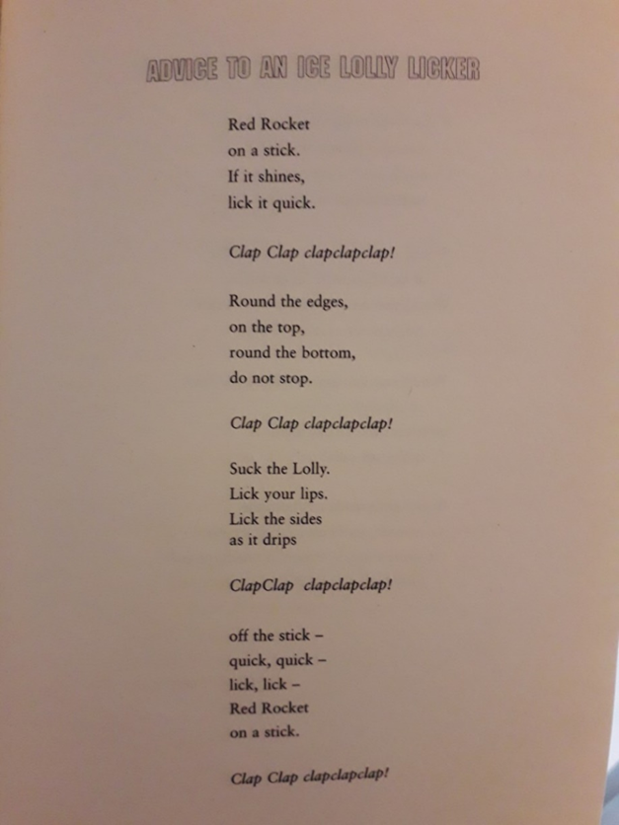

SOUNDS GOOD!
Sausages sizzle,
Crispbreads crack;
hot dogs hiss
and flapjacks snap!

Bacon boils
And fritters fry;
Apples squelch
In apple pie.

Baked beans bubble,
Gravy grumbles;
Popcorn pops,
And stomach rumbles….
IM HUNGRY!
Judith Nicholls

AFTERNOON
- ERIC – Read a book of your choice.
- PE – This morning, you may have completed Joe Wickes Friday keep fit challenge.
- Welsh
Using your language mat for help ( if needed) I’d like you to write a profile about yourself. You can add pictures if you wish. I have wrote some examples about myself to give you an example. You may like to read it to see if you understand what I’ve wrote.

Mr Williams ydw i.
Dw i’n byw yn Wrecsam.
Mae fy mhen blwydd yn Fis Mai.
Mae gen i gi o’r enw Jasper.
Mae gen i un brawd o’r enw Matthew.
Dw i’n hoffi bwyta pysgod a sglodion, coffi a siocled.
Dw i ddim yn hoffi bwyta cyrri poeth neu olives.
Dw i’n hoffi gwisgo treiners a chrys t.
Dw i’n mwynhau rhedeg, rygbi, nofio a darllen.

(you may have noticed some of my words have changed such as mis to fis. These are mutations. Don’t worry about these)

Have fun and stay safe.
Mr Williams

