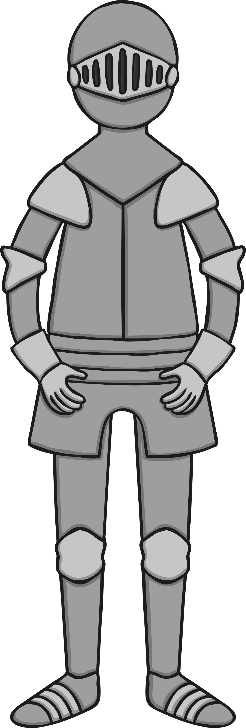

C

A

S

T

L

E

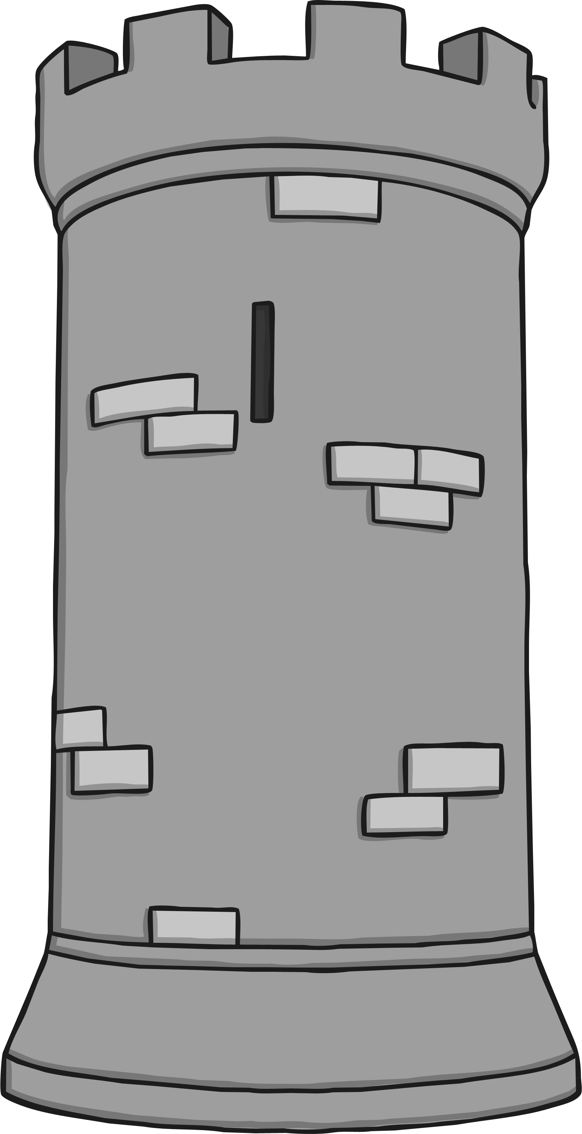

My Castle and Knights Acrostic Poem

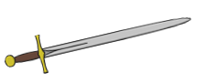

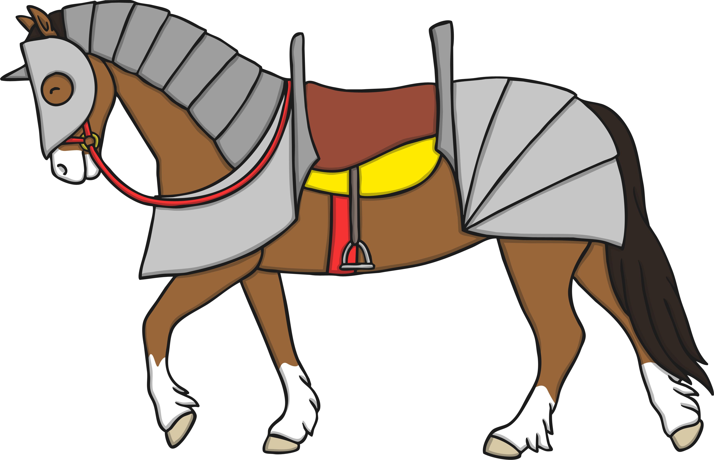

C

A

S

T

L

E

My Castle and Knights Acrostic Poem



C

A

S

T

L

E

My Castle and Knights Acrostic Poem

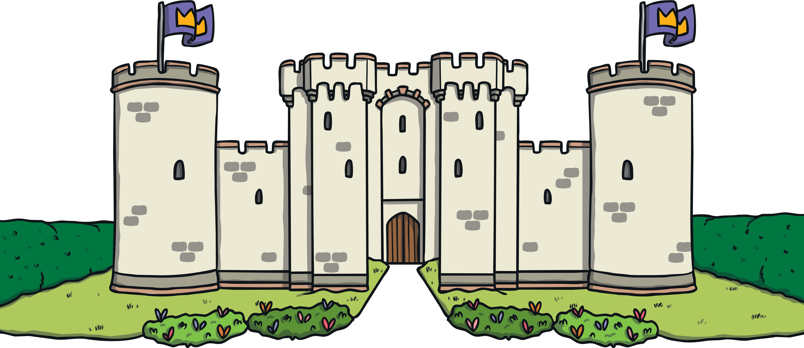

C

A

S

T

L

E

My Castle and Knights Acrostic Poem

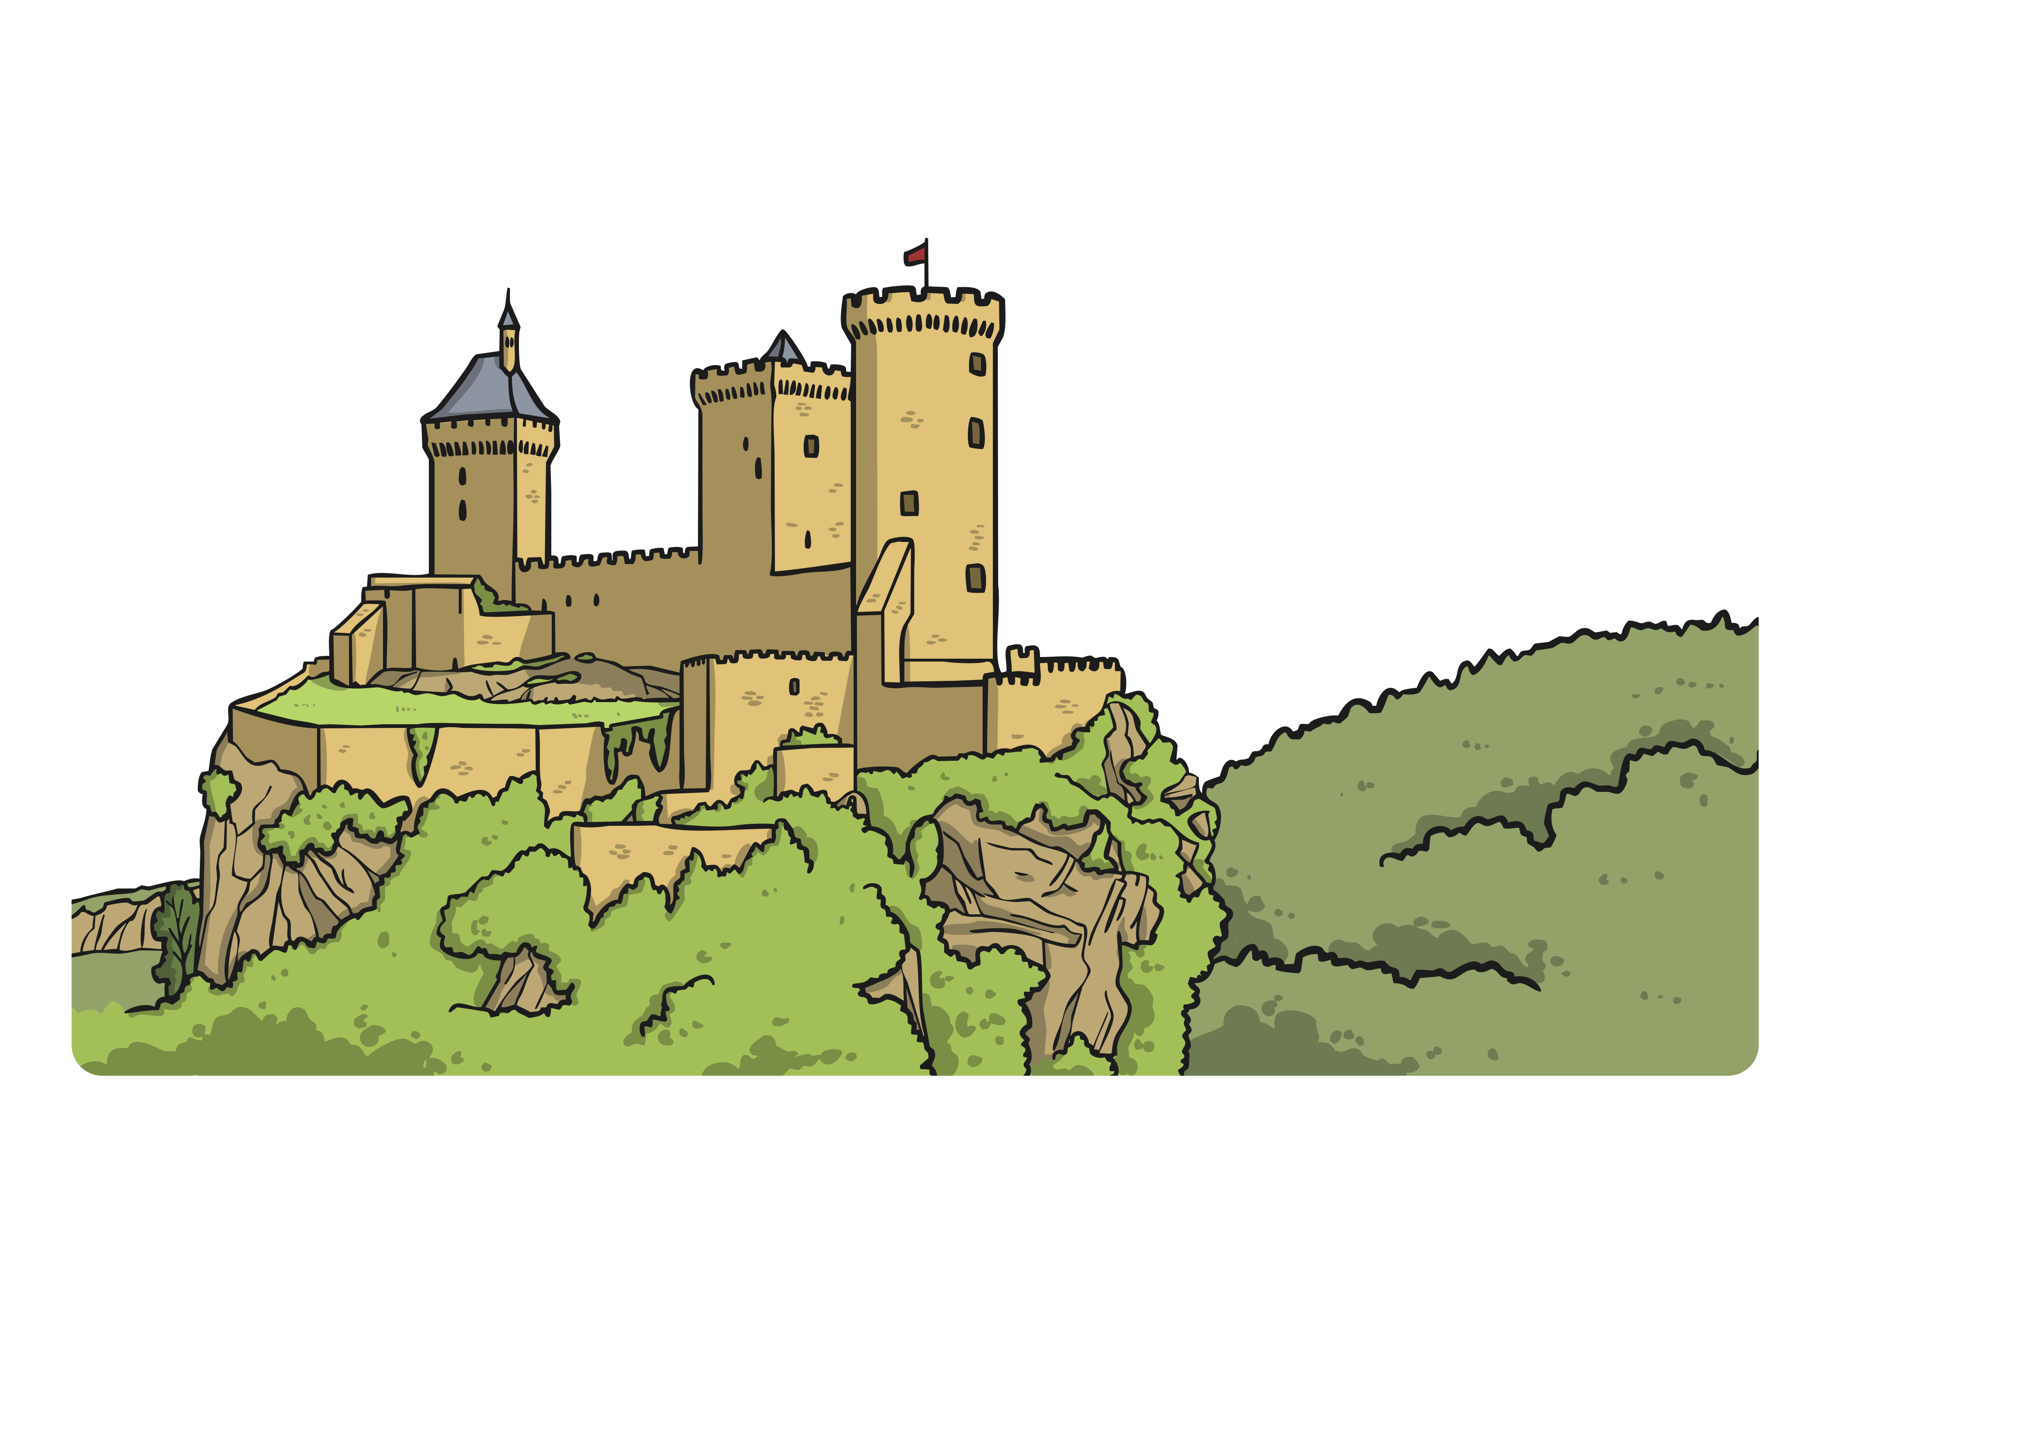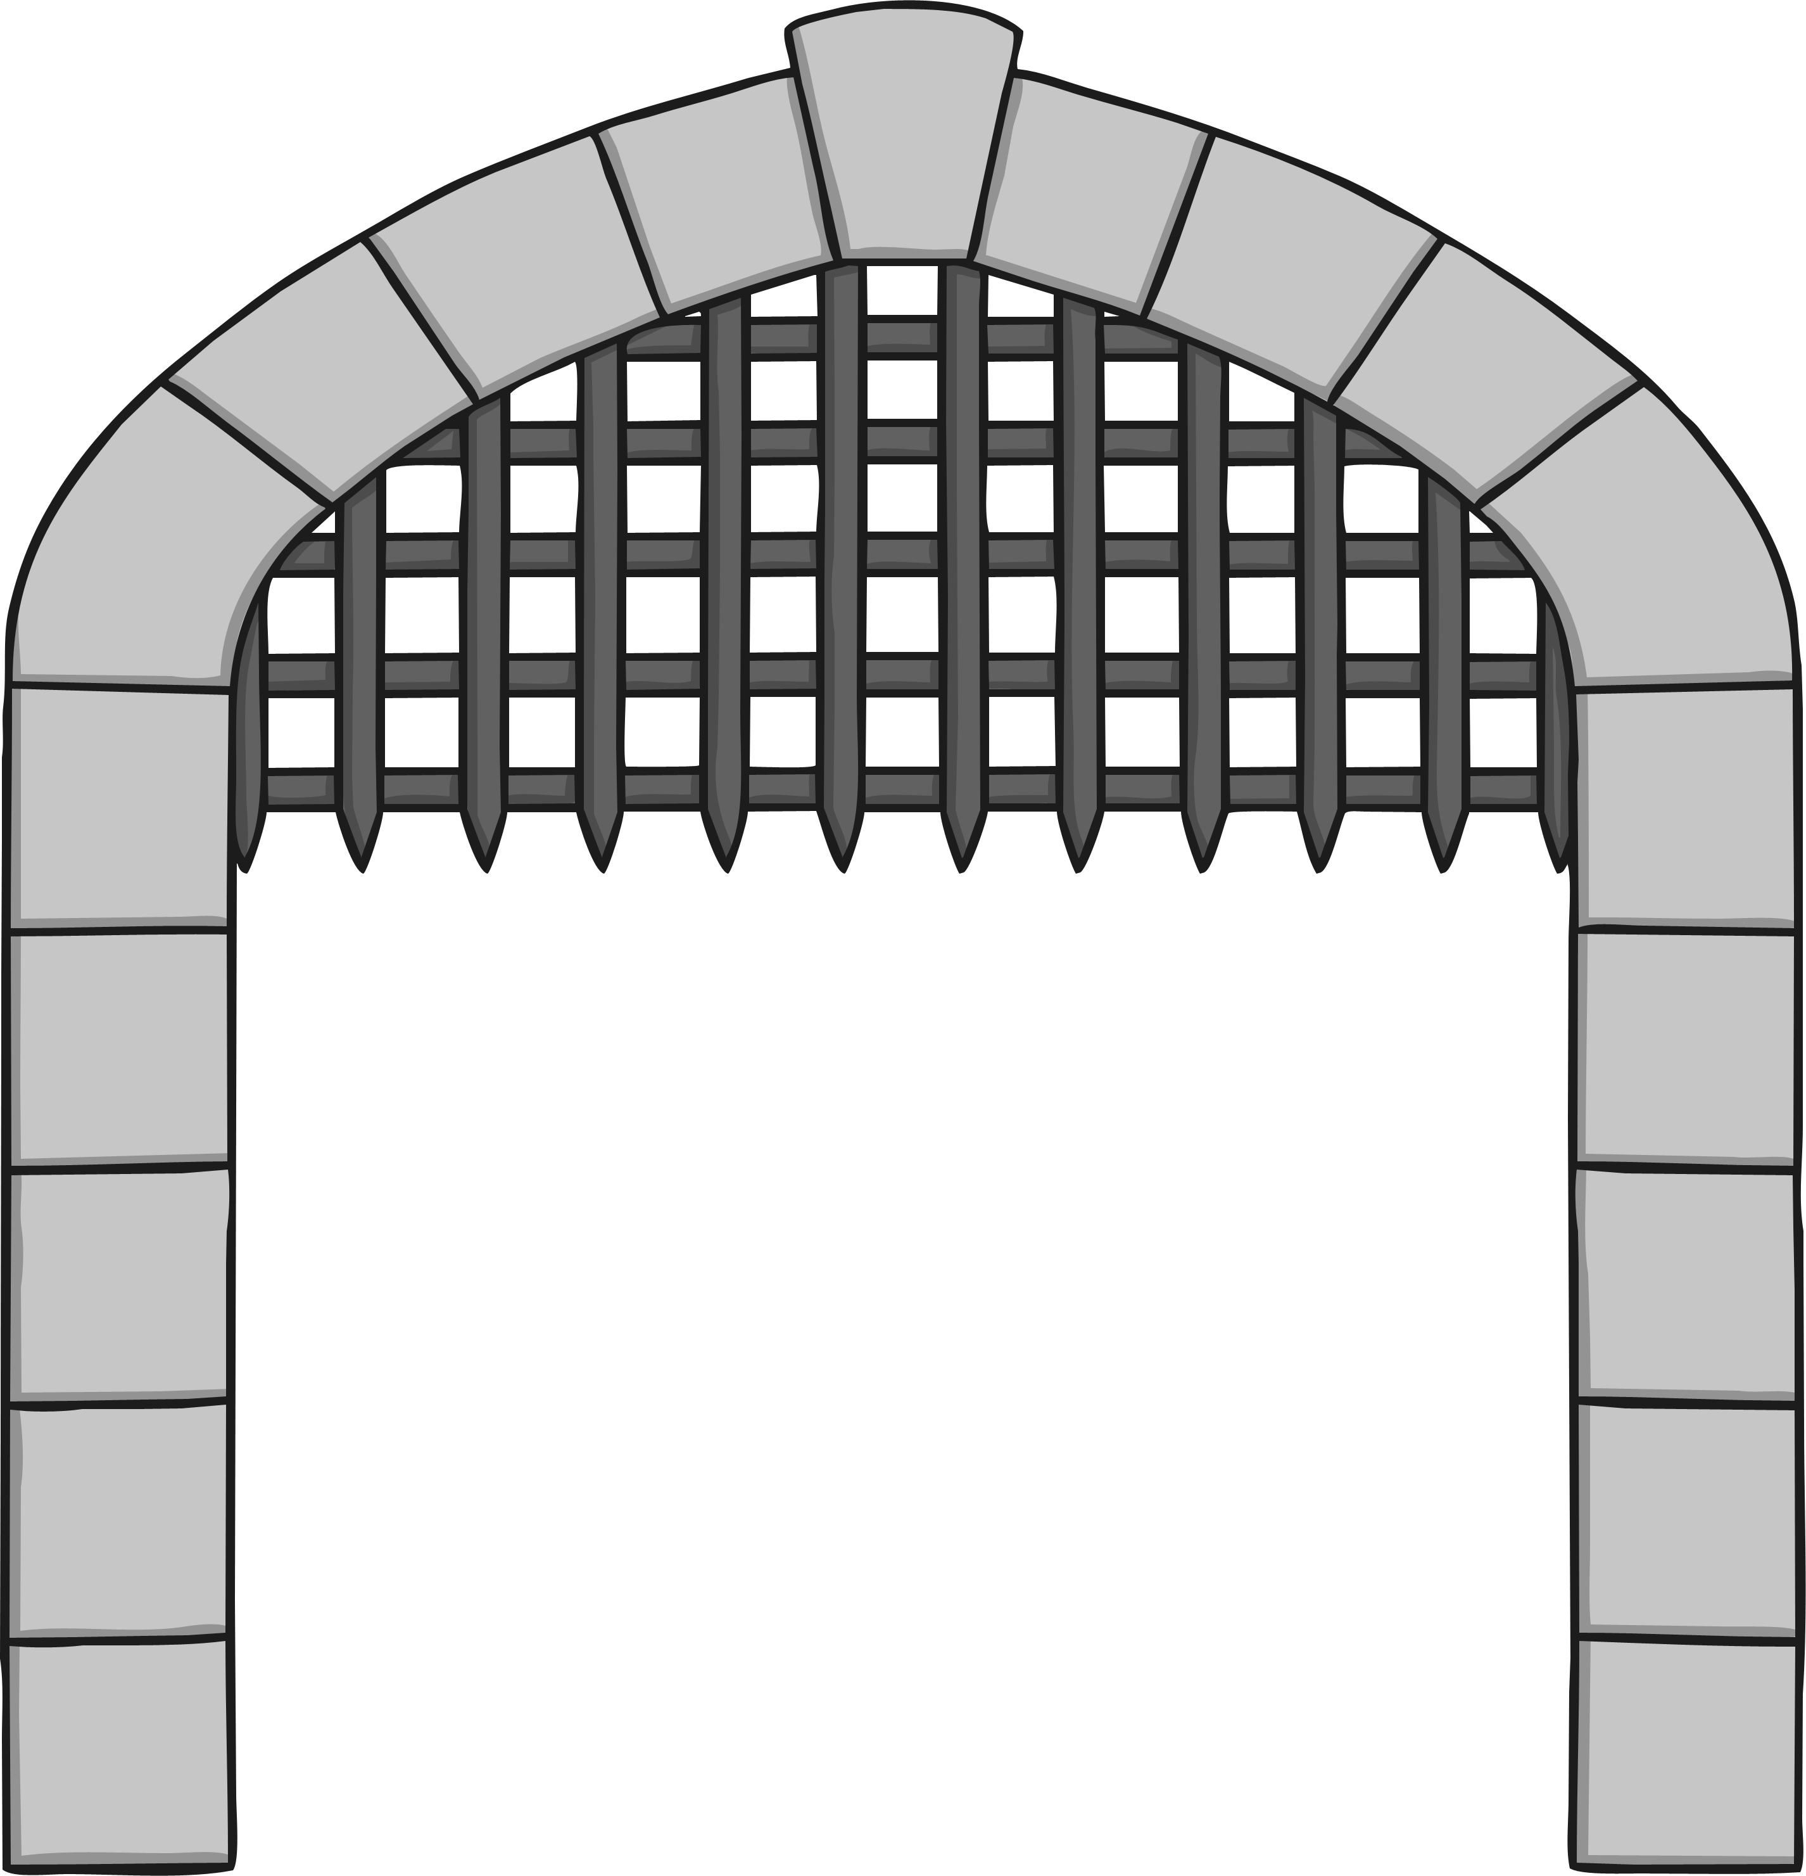

C

A

S

T

L

E

My Castle and Knights Acrostic Poem