Reception Home Learning Week 3 Eggs Day 5
Friday 20th January 2021
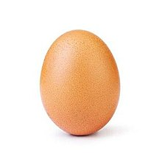

Activity 1 - Maths (Number Bonds to 5): Continue to practice the ‘Number 5 Rap’ until you know it off by heart with the actions as shown in the maths video earlier in the week.
Activity 2 - Literacy: You will need: Pencils and paper. Watch the Phonics Scrambled Eggs Zoom video lesson posted on the school app and Google Education (this can be accessed through your Hwb account) and work along with it. Try to read a book on your Bug Club account daily in addition to the above activities if you can.
Activity 3 – Topic (Problem Solving): I’d do this one outside! Use the unboiled egg you have kept and ask the children to find a way of protecting it if it fell from a tree or bush! Think about wrapping it in newspaper, bubble wrap, material, cotton wool, make a parachute, put it in a padded box, etc? Choose the idea you think will work best eg wrap the egg in bubble wrap, sing ‘Humpty Dumpty’ then try dropping it! Did your idea work or did you get scrambled egg?! How could you improve on your idea? Have fun and send me some photos on dojo if you can.

