**Monday 11th January**

**Money Activity- 1 dot**

**How much money does Spongebob have?**



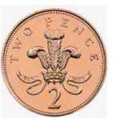     

**How much money does Scooby Doo have?**

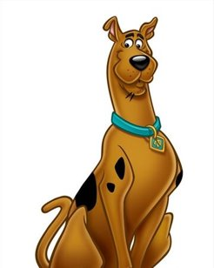

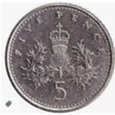  

**Who has the most money?**

**Monday 11th January**

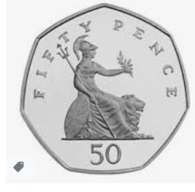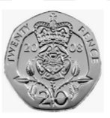**Money Activity- 2 dot**

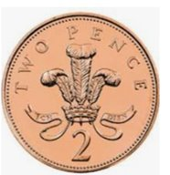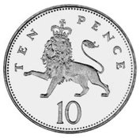****

Spongebob wants to buy a cheeseburger for 89p. Does he have enough money? How do you know?

How much more money does Spongebob need to buy a cheeseburger?

**Monday 11th January**

**Money Activity- 3 dot**

****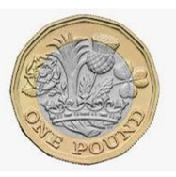****

How much money does Spongebob have? (Remember to use the £ sign and a decimal point .)

Spongebob wants to buy a cheeseburger for 89p and a ball for 35p. Does he have enough money to buy them both? How do you know?

Spongebob decides just to buy a cheeseburger. If he gives the shop assistant, the £1 coin, how much change would he have?

CHALLENGE- How many balls could Spongebob buy with his money?