Reception Home Learning Week 3 Eggs Day 4
Thursday 20th January 2021
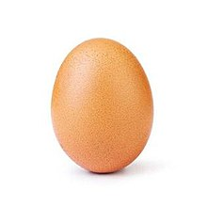

Activity 1 - Maths (Number Bonds to 5): Try to learn the ‘Number 5 Rap’ with the actions as shown in the maths video earlier in the week.
Activity 2 - Literacy: You will need: Pencils and paper. Watch the ee Zoom video lesson posted on the school app and Google Education (this can be accessed through your Hwb account) and work along with it. Try to read a book on your Bug Club account daily in addition to the above activities if you can.
Activity 3 – Topic (Welsh, music, PE): Use one of the hard boiled eggs and a spoon to practice your hand eye coordination to have an egg and spoon race. If you would like to make it more challenging you could create your own obstacle course. To relax after this activity search ‘Canu Canu Aderyn Melyn’ on YouTube. Listen to the song a few times and try to join in if you can.

