Reception Home Learning Week 3 Eggs Day 3
Wednesday 20th January 2021
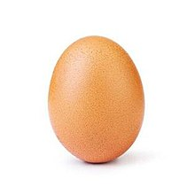

Activity 1 - Maths (Number Bonds to 5): Do the opposite to yesterday! Write the number sentence for the children and they must then act it out using the 5 eggs and nest. For example you write 4+1= and they put 4 eggs in the nest and 1 on the table then count how many altogether to make 5. Repeat for 1+4=, 3+2=, 2+3=, 5+0= and 0+5=. Hopefully by now they are starting to get the idea it will always be 5! Please stick to bonds to 5 as we are aiming for them to know them off by heart by the end of the week and including other numbers will confuse them.
Activity 2 - Literacy: You will need: Pencils and paper. Watch the ai Zoom video lesson posted on the school app and Google Education (this can be accessed through your Hwb account) and work along with it. Try to read a book on your Bug Club account daily in addition to the above activities if you can.
Activity 3 – Topic (Creative): Use the egg box to create something wonderful! Make a game, a crocodile, cut it up to make flowers, add other boxes to make a magical city? It’s up to you, have fun and post me your ideas on Dojo. I can’t wait to see what you come up with!

