Year 6 Home Learning- Tuesday 12th January
- 9am- Keep fit session with Mr Evans (the video can be found on the school app or Google Classroom)
- 9.30 am- TT RockStars
- 10.00 am- Maths- Multiples , common multiples and lowest common multiples- during yesterday’s Maths lesson, we revised multiples and identified common multiples and lowest common multiples. Complete the following activities to test your knowledge of multiples (you can record the answers on paper if you cannot print out the sheets):
- Lowest common multiples colouring activity
- Finding common multiples
- Common multiples activity sheet (the answers are included on the last page for you to check your work AFTER completing it)
- Play the common multiples game (you will need a dice, somebody to play with and two different coloured pens or pencils)
- 11am- 12 pm-Literacy- answer ‘The Lighthouse’ comprehension questions and complete the Literacy work from yesterday.
- 1.00-Reading activities- you can do ERIC reading with a book you have at home, listen to an audio book, read one of your Ereaders on Bug Club, listen to a story being read by a famous person on the following website https://www.storylineonline.net/books/arnie-the-doughnut/ . There are additional reading resources available on Google Classroom if you would like to use them.
- 1.30pm- Welsh/ Helpwr Heddiw- choose a different activity every day from the following: download the Campau Cosmig app and play the games, rehearse the patterns on the language mat, answer the question Beth ydy dy hobi di? using the variety of sentence patterns we have done in class, write down as many questions from the language mat as you can in a minute, play alibi with a family member or play Guess Who? with a family member. There are additional reading resources available on Google Classroom if you would like to use them.
- 2.00-3.00pm- Topic/Art- Choose one of the Olympic logos below used during the 1960’s and recreate it using a medium of your own choice (painting, watercolours, pastel, pencil sketch, etc).
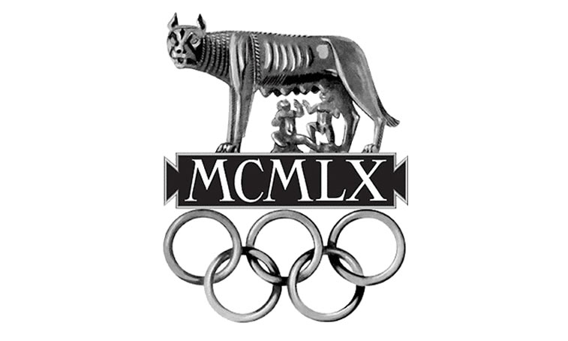Rome 1960

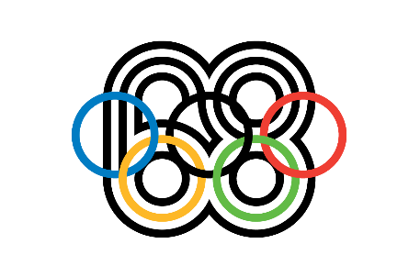
Mexico 1968

