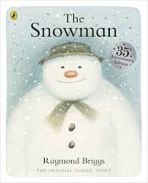
Nursery Home Learning
The Snowman!

Monday
9.00 - 9.30 – Daily Exercise
Choose an activity from any of the following:
Andy's Wild Workout
https://www.bbc.co.uk/programmes/p06tmmvz
BBC Supermovers
https://www.bbc.co.uk/teach/supermovers/ks1-collection/zbr4scw
Cosmic yoga
Youtube or https://cosmickids.com/
9.30 – 10.20 – Literacy/Numeracy/Creative
Listen to the original story of The Snowman by Raymond Briggs.
https://www.youtube.com/watch?v=8ka-QWPFVnE
Watch the story and then discuss the story at the end discussing the following questions.
- Did you like this story? What was your favourite part?
Make some puppets of James and the Snowman by either using the templates provided to cut out or by drawing and colouring your own, cut them out and then stick them onto lollipop sticks. You can react the story and then use them to play with. What would James and the snowman like to do together?
10.20 – 10.30 – Phonics
(A video will be uploaded to the class dojo to support this activity).
Choose a phonics activity from the activity sheet provided. Choose an activity from the phonics sheet to play.
10.30 – 11.00 – Break / Snack
11.00 – 11.20 – Numeracy/Music
Use the Maths and Music sheet provided to learn to sing the songs and count the snowmen, you could use objects to help count, snowman pictures of even your fingers.
11.20-11.30 – Story/Song Time
Choose a story to read together from home you could watch a story being read online or you can choose some of your favourite songs to sing using the website we use in school.
https://www.bbc.co.uk/teach/school-radio/nursery-rhymes-songs-index/zhwdgwx

Tuesday
9.00 - 9.30 – Daily Exercise
Choose an activity (See Monday’s Links).
9.30 – 10.20 – Literacy
Re-watch the story and then discuss the story at the end discussing the following questions.
- What do you think might happen next after James finds that the snowman is alive? What could they get up to together?
Using the puppets from yesterday think about what the characters could do once James realises that the snowman is alive. Draw a picture of what you think they could be doing. They could be playing a game, eating something, going to visit someone, it is up to you, use your imaginations. I look forward to seeing what you come up with.
10.20 – 10.30 – Phonics
Choose a phonics activity from the activity sheet provided.
10.30 – 11.00 – Break / Snack
11.00 – 11.20 – Numeracy
Count the snowman’s button! – You can be as creative as you like you could draw your own and write numbers 1-5 or even 1-10 on their hats. You can stick on the correct number of buttons, stickers, beads etc onto the snowman. You could even use finger painting or use lollipop sticks for his body. There are some ideas below for you, there is a template to use if you wish.
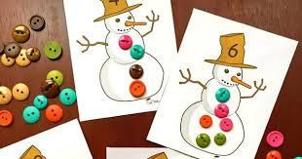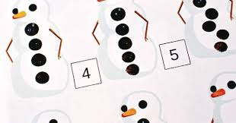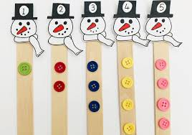
11.20-11.30 – Story/Song Time

Wednesday
9.00 - 9.30 – Daily Exercise
9.30 – 10.20 – Literacy
(You could watch the film beforehand one afternoon as a treat)
The book was very popular when it was first written that they made a small film based on it. The film continues once James find the snowman alive, do they get up to the things you thought they might?
Watch the film and then draw a picture of your favourite part of the story.
https://www.youtube.com/watch?v=nGmOiccZFJM
10.20 – 10.30 – Phonics
Choose a phonics activity from the activity sheet provided.
10.30 – 11.00 – Break / Snack
11.00 – 11.20 – Numeracy
Watch the Video clip all about 2d shapes. Go on a shape hunt around your home or even outdoors. You can collect them and the sort them into circles, triangles, and squares. Can you find at least 2 of each shape?
11.20-11.30 – Story/Song Time

Thursday
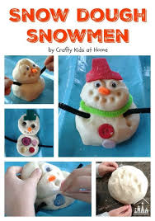
9.00 - 9.30 – Daily Exercise
9.30 – 10.20 – Fine Motor skills
Create your own snowman using playdough, you can collect items from around your home to use for his arms, eyes, nose, and mouth. You could even make a family of snowmen of different sizes and then put them into size order from the Biggest to smallest.
10.20 – 10.30 – Phonics
Snowman begins with the sound ‘S’, can you think of other objects in your house that starts with ‘S’? Find 5 items around your home that starts with the sound ‘s’ and take a picture of them to send on the class dojo. I can not wait to see what you find!
10.30 – 11.00 – Break / Snack
11.00 – 11.20 – Numeracy
Using the different shapes create your own snowman. You can talk about the different shapes first and even see if you can name them. Then cut them out and then sort them into different groups before using them to stick to create your shape snowman.
11.20-11.30 – Story/Song Time

Friday
9.00 - 9.30 – Daily Exercise
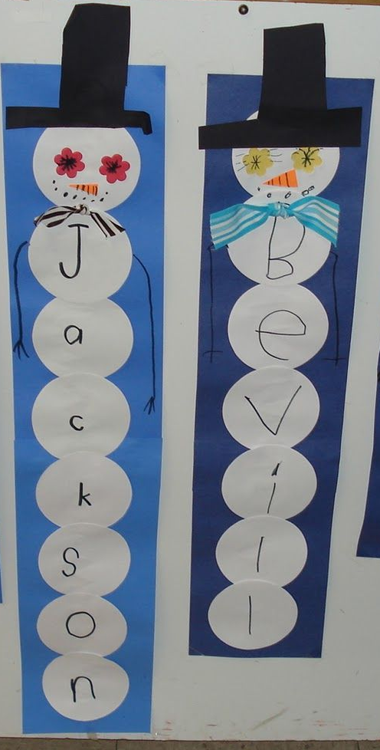
9.30 – 10.20 – Literacy/Creative
We are going to focus on our names. Using circles of white paper or white paper plates if you want to make a big snowman, create a name snowman like in the picture. For each letter of your name use 1 circle to create your name on the snowman’s body to put on display in your home or bedroom. Discuss the letters, tracing them with your finger. The more you see your name the more you will recognise it. You could practise writing or going over your name on paper or just look at the first letter of your name. If you can already write your full first name, practise writing it to make all the letters the same size.

10.20 – 10.30 – Phonics
(A video will be uploaded to the class dojo to support this activity).
Snowman begins with the letter ‘s’, you found other items yesterday that also start with the ‘s’ sound. Using sand/flour on a tray/plate have ago at writing the letter ‘s’ remember you can shake the tray to start again. You can even use it to make patterns and pictures.
10.30 – 11.00 – Break / Snack
11.00 – 11.20 – Numeracy
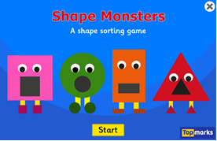
Play the shape sorting activity called shape monsters online.
https://www.topmarks.co.uk/early-years/shape-monsters
11.20-11.30 – Story/Song Time

Thank you for your continued support. I have enjoyed looking through and commenting on all the children’s work that has been sent to me through the class dojo. I look forward to seeing this week’s work. If you would like a paper copy of this pack, please contact school or message me on dojo. The videos to support the work will follow.
Many thanks Mrs Hughes

