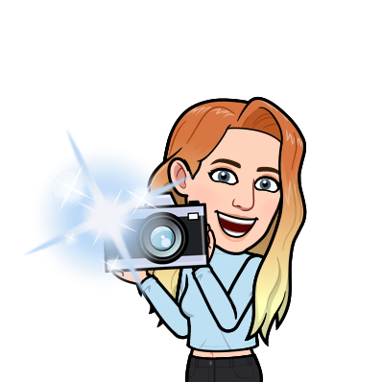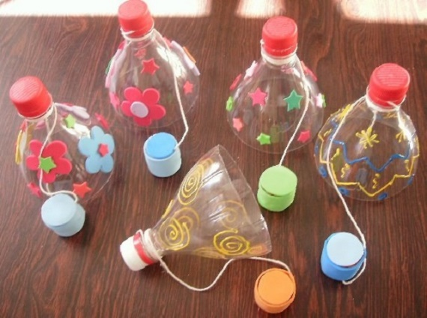

**You will need:**

* Big plastic bottle
* Bottle lid
* String or ribbon
* Scissors
* Sticky tape or glue
* Decorations: glitter, sharpies,

stickers, tissue paper, washi tape

* A grown up to help

**Instructions:**

* First, take your plastic bottle and cut off the top section (about a third of the bottle)
* Next, decorate your bottle! You can use whatever you have in your house. If you don’t have stickers, you could draw pictures on some paper, cut them out and glue them onto your bottle.
* After that, get your extra bottle lid and tie the string around it. You can secure the string with some sticky tape.
* Then tie the other end of the string around the bottle nozzle.
* Lastly, play with your cup and ball game! And if you can, send Mrs Bayraktar and I a picture - we would love to see your fantastic games.