Hi Year 4,
I hope you are all well.
Here are some activities to complete at home. I have put them on class dojo as well as HWB/ Google Classroom in case some have difficulty with HWB. Please ask Miss Evans in the school office to print you a hard copy if you wish.
Please do what you can and don’t worry if you don’t manage to complete everything. These are strange times and we will get through it together!
You have all been very sensible in school in our bubble washing hands and following the instructions so well done! As Mrs Brown has said you can continue to use TT Rockstars to practice times tables and bug club to access books online.
It’s not the same learning online. It is much better face to face in the classroom but fingers crossed we will back together soon. We will all do our best
You can send me any work or photos via class dojo or on HWB/Google classroom. If you do it on paper/ work book bring it back to school to show me when we are back in.
Take care everyone!
Thursday 08th October
Maths – We have been learning lots about measuring in class using mm, cm and metres.
L.I. To convert between units of measurement.
* Can you work out what is behind the question marks?
- 1 cm = ? mm
- 5 cm = ? mm
- 10.5cm = ? cm 5mm
- 20 mm = ? cm
- 1m 50cm = ? cm
- Estimate and order objects.
Pick 5 items in your home to measure.
First order from shortest to longest.
Estimate how long in cm and then measure to see if correct.
Second measure from shortest to tallest. You could measure soft toys like teddies or toy cars or books, cds and dvd covers.

Those that want an extra challenge ( 3 dot) can you record in different ways e.g in cm and mm.

Our activity in school was going to be : throwing a bean bag and throwing a basketball and measuring using measuring tapes. Unfortunately, we can’t do that. However, if you have something to throw in the garden such as a ball or teddy. (don’t use anything valuable ) you could measure using non-standard measurements e.g. measure how far you have jumped or thrown an object using length in pencils or pens (the same size felt tips)
If you have a tape measure then fantastic! Please use that!

Literacy – To write adverb ‘ly’ sentences. See class dojo for pictures.
Verbs are doing or action words. E.g. running, swimming, singing.
Adverbs describe the verbs e.g. Quickly, I ran to the beach.

Afternoon
Welsh –
- Have a conversation using a language mat.

- We have been describing the weather. You could make a poster using welsh symbols/ drawings and matching sentences.
Mae hi’n = It is.
Heulog, boeth, oer, bwrw glaw, wyntog, stormus.

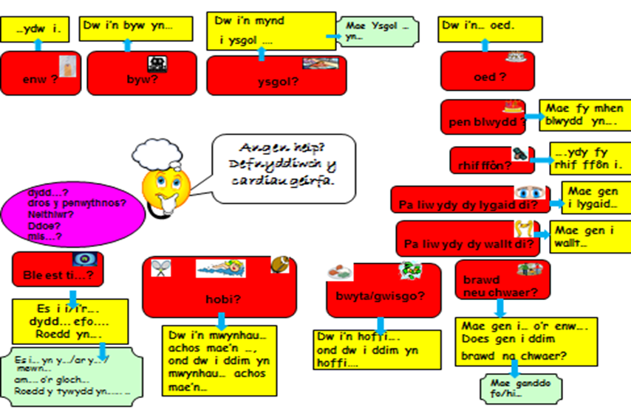

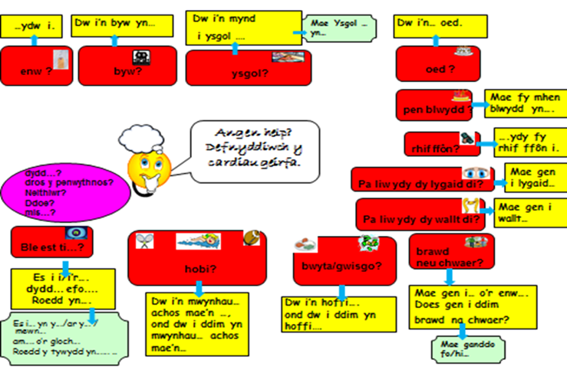
PSHE/ Jigsaw
To help fill in a one page profile back in school I would like you to answer two questions.
- What do people like and admire about you?
Ask your family to tell you. Admire is a bit different to like. I admire Captain Tom for being kind and I admired my Grandad for being brave as a soldier in the war.
- What’s important to you?
Mine would be my dog, the sea, owls and running. What would yours be?

Friday
Numeracy – Perimeter activity.
Perimeter is the distance all around a shape.
Can you find some square and rectangular shaped objects in your home. E.g books, dvd covers, cd cases, cereal boxes and measure with a ruler. Measure the length and width.
Can you write the perimeter of each rectangle or square by adding all the sides together.

Literacy –
To write some ‘ed’ sentences. See class dojo for pictures to help.

Afternoon
P.E. – Joe Wickes activity on youtube or some laps of your garden like Sir Captain Tom. Keep a tally of how many laps you have done.

You may also read books on bug club and practice times tables using TT Rockstars and BBC SuperMovers.

Take care and contact myself or Mrs Brown if you need anything
Mr Williams
WilliamsS1794@hwbcymru.net

