Hi Year 4,
I hope you are all well.
Here are some activities to complete at home. I have put them on HWB/ Google Classroom as assignments as well as on class dojo incase some have difficulty with HWB. Please ask Miss Evans in the school office to print you a hard copy if you wish.
Please do what you can and don’t worry if you don’t manage to complete everything. These are strange times and we will get through it together!
You can continue to use TT Rockstars and BBC Supermovers to practice times tables and bug club to access books online. ictgames.com also has some good free online games.
Take care everyone !
Thursday 08th October
Maths – PERIMETER
Please look at the perimeter powerpoint I put on google classroom to help.
Look at pages 5 and 6. Please don’t worry about compound/ irregular shapes. We look at T and L shapes later in Year 4 and Year 5. We are just going to look at rectangles.
Remember the perimeter is the distance all around a shape.
You may have noticed last week that you do not need to know the measurement of each side. If you measure the length and width you know the opposite sides are the same.
Answer the sheet attached. Please answer sheet 1. Unfortunately I couldn’t take out the answer pages, so no peeking
Literacy – Thursday Part A - To spot good features of recount writing. A WAGOLL. What A Good One Looks Like… I will attach some different types of recount writing for you to read. I’d like you to see which is your favourite and check if they have used features of recount.
To remind you –
- Write in the past tense e.g. I went to… We travelled.. instead of I am going..
- Chronological order/ time order – sequenced events properly in the correct order.
- First person – I
- A list sentence? E.g. I packed shoes, a coat, swimming trunks and a towel.
I bought sweets, crisps, bread and a drink.
- Have they used paragraphs and can you spot punctuation such as capital letters and full stops.
Afternoon
Welsh –
- Have a conversation using a language mat.

- Can you add to the map the following places – Cefn Mawr, Rhyl, Anglesey, Porthmadog, Bala, Cardiff, Swansea.

- Next to those places can you draw a weather symbol.

- Write me some sentences about those places

e.g. Yn Rhyl mae hi’n heulog = In Rhyl it is sunny.
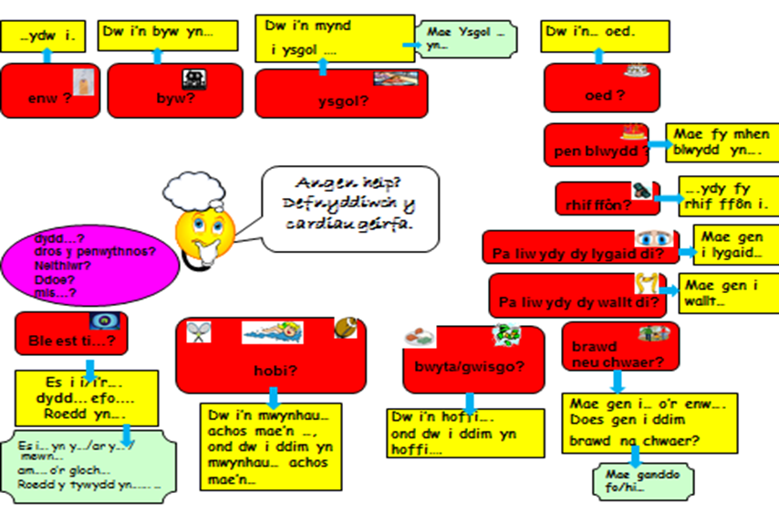

You can use this map or draw your own.
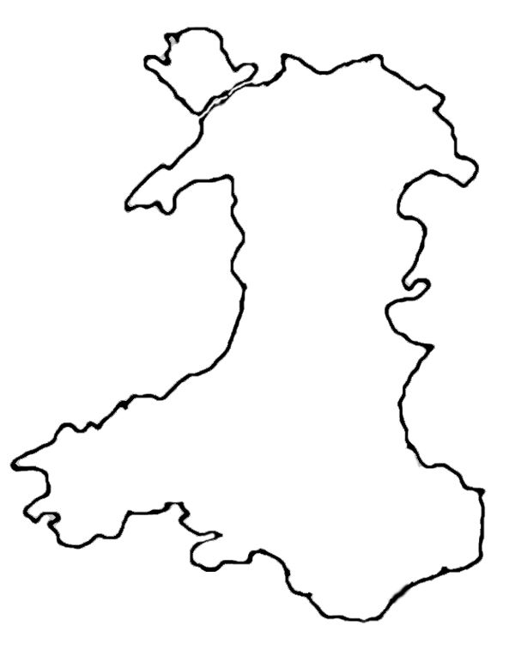

PSHE/ Jigsaw
To help fill in a one page profile back in school I would like you to answer one last questions.
3. How can we support you in school?
e.g. I need some help with maths.
I like to sit at the front.
I prefer to write with a pen instead of using a laptop.
This is not for our 1 page profile but its nice to share how we can relax when not working.
4. How do you like to relax?

Friday
Numeracy – Perimeter activity.
Playground perimeter – can you work out the perimeters of the various part of the playground. Just page 1 – rectangles. Not page 2.
You could also design your own playground – page 3. Tell me the perimeter of each part of your playground.
I will attach the sheets. We will look at area in school.
Literacy – Friday Part B.
(If you wish to do part B on Thursday after looking at good examples you may do so)
I would like you to write me your recount writing today – using your best writing.
You can do it on paper and take a photo or type up and send as an assignment. Next week we will share them in class. You can read them out to others and we will print them off to mark with green and pink highlighters. Think pink – what you could improve. Good to be green – good features.
Remember the features I’m looking for from yesterday .
- 1st person e.g. I and We
- Time order – put what you did in the correct order.
- Past tense – I went. I travelled. I swam.
- 5 w sentences or 5 w paragraph
e.g. when, who, where, what, why.
e.g. Last month I went to Rhyl with my Mum and Dad. We travelled by car to go to the beach to have fun.
* Include some ly and ed sentences you did a great job with last week.

- Good punctuation – capital letters, full stops and paragraphs.
- Remember to write in pargraphs.
You may choose to write about one of the following :
- The best day ever
- My favourite holiday
- A day at the beach
- A trip to Anfield or Old Trafford (or another stadium)
Or you could make one up. It could be a trip to the moon, the jungle or Disney land.
I look forward to reading your recounts.
Afternoon
P.E. – Joe Wickes activity on youtube or some laps of your garden like Sir Captain Tom. Keep a tally of how many laps you have done.

You may also read books on bug club and practice times tables using TT Rockstars and BBC SuperMovers.
Our class assembly would have been about Harvest. I will attach a powerpoint for you to look at.

Take care and contact myself or Mrs Brown if you need anything
Mr Williams
WilliamsS1794@hwbcymru.net

