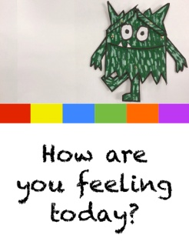
Reception Week 2 Activities Friday 16th October 2020
This week we will be learning using the book ‘The Colour Monsters’ by Anna Llenas
Maths: Today we will finish the counting book you started to make yesterday. Choose numbers you feel that the children may need to practice and write the number on a page and draw that number of monsters. Repeat for different numbers until your book is full. This may be 1, 2, 3, 4, 5 if they still need practice with these. Others may find doing 6, 7, 8, 9, 10 suits better or if they find this easy making pages of teen numbers.
Literacy: Today we will practice the letters e u r which we learnt in school just before our Home Learning began. You have lesson videos and a related game in your Bug Club account. Please watch the videos and play the game then practice forming the letters. Continue to practice s a t p/ i n m d instead if they still need to do this.
Topic (Outdoor Learning): Make a collection of leaves, seeds, nuts, stones, flowers, twigs, mud etc and use these to make a face. Try moving the objects so that the face shows different feelings eg can you make it happy, sad, angry?

Looking forward to seeing you all back at school on Monday.

