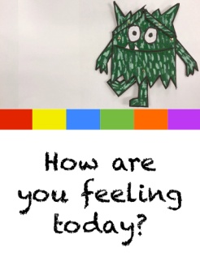
Reception Week 2 Activities Thursday 15th October 2020
This week we will be learning using the book ‘The Colour Monsters’ by Anna Llenas
Maths: Over the next two days we will be making a monster counting book. Today we will make the book and decorate the front cover and then finish it off tomorrow. Google ‘How To Make A Quick and Easy 8 Page Mini-Booklet From 1 Piece of Paper’ or click on the link below if you are accessing this via Google Classroom. Make the book together and decorate the front cover with a monster picture and write ‘My Book’ and their name.
Literacy: Today we will practice the letters g o c k which we learnt at the beginning of the term. You have lesson videos and a related game in your Bug Club account. Please watch the videos and play the game then practice forming the letters. Continue to practice s a t p/ i n m d instead if they still need to do this.
Topic ( Technology/Feelings): Go to their hwb account and log in then look for the 2Simple icon and click on this. A lot of different icons will come up but look for the yellow one that says JiT. Once in click on the black tab at the top which says mix. Click on the page with a blue rectangle and a box underneath which says write about your work then click on the green tick. Have a play with the drawing and writing tools. Once confident try drawing a feelings monster and type in underneath ‘ I am ___’ (then either happy/ sad/ relaxed/angry etc depending on how your monster feels!). If you are struggling to access the account please Dojo me. Don’t be a frustrated monster as if all else fails just draw a picture of a Feelings Monster and write ‘I am ___’ instead, no worries!

