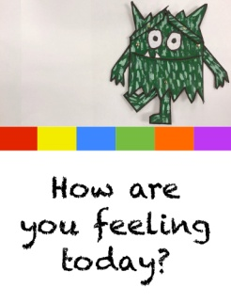
Reception Week 2 Activities Wednesday 14th October 2020
This week we will be learning using the book ‘The Colour Monsters’ by Anna Llenas
Maths: Make a collection of sticks and set the children the task of making different shapes with them. Initially ask them to make a shape with 3 sticks (triangles), then 4 (use 4 sticks the same length to make a square or 2 longer and 2 shorter ones to make a rectangle). If they find this easy give them 5 sticks to make 5 sided shapes (pentagons) or 6 sticks to make 6 sided shapes (hexagons).
Literacy: Today we will practice the letters g o c k. You have lesson videos and a related game in your Bug Club account. Please watch the videos and play the game then practice forming the letters. It is very important that they form them as shown in the video so they do not later have to unlearn wrong habits. If you find that they still need to practice s a t p/ i n m d continue to practice these instead.
Topic ( Creative): Have fun making a feelings monster puppet. You could use a paper plate or bag, old sock or glove and decorate with felt pens, paint, buttons, glitter, ribbons, cut out pictures from magazines, pompoms, anything you have to hand around the house. Get creative and do it any way you like. Try using the internet with the children to research some ideas first... ‘Paper Bag Monsters’ comes up with some lovely ideas to get you started. Enjoy!

