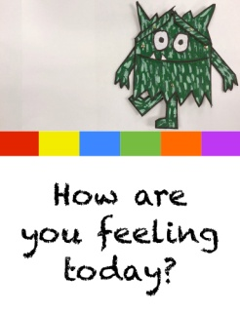
Reception Week 2 Activities Tuesday 13th October 2020
This week we will be learning using the book ‘The Colour Monsters’ by Anna Llenas
Maths: Practice the names of the shapes circle, triangle, square, rectangle by going on a shape hunt around your home. You could extend their learning by adding in diamond and semi-circle. Draw the shapes down the side of a piece of paper and ask the children to make a mark next to the shape they find to make a simple tally. If this is tricky for them just make collections of the different shapes found.
Literacy: Today we will practice the letters i n m d which we learnt at the beginning of the term. You have lesson videos and a related game in your Bug Club account. Please watch the videos and play the game then practice forming the letters. It is very important that they form them as shown in the video so they do not later have to unlearn wrong habits.
Topic ( Welsh): Google ‘Lliwiau’R Enfys song by John ac Alun’ or click the link below if you are using Google Classroom. Watch the video and try to join in with the song to practice the Welsh colour names.

