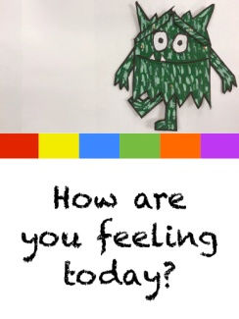
Reception Week 2 Activities Monday 11th October 2020
This week we will be learning using the book ‘The Colour Monsters’ by Anna Llenas which you can find being read on YouTube ( Google ‘The Colour Monster – Read by Sherry’ or click the link below if you are accessing this via Google Educate on your Hwb account). They have also been introduced to the book in school last Monday. This week we will focus on learning about shapes and make a number book in Maths, practice all of the letters we have learnt this term for Literacy ( satp, inmd, gock, uer, hbfl) and think about our feelings and colours in our Topic activities.
Maths: Learn the names of the shapes circle, triangle, square, rectangle. If they already know the shape names extend their learning by talking about how many sides/ edges or corners they have (circle- 1 edge no corners, triangle 3 s edges and 3 corners, square 4 edges that are the SAME length and 4 corners, rectangle 4 edges of different length and 4 corners). Use the different shapes to make a shape monster picture. If you are accessing via Google Educate click on the link below to find the activity sheet. If you are unable to access Google Educate draw or cut out the different shapes to make your monster eg circle head, square body, rectangle arms, triangle hat.
Literacy: Today we will practice the letters s a t p which we learnt at the beginning of the term. You have lesson videos and a related game in your Bug Club account as well as stories to read using these letters. Please watch the videos and play game then practice forming the letters. It is very important that they form them as shown in the video so they do not later have to unlearn wrong habits.
Topic ( Music and Movement): Google ‘If You Are Happy and You Know It Bare Foot Books’ or click the link below if you are using Google Classroom. Watch the video and try to join in with the song and actions. Imagine you are the different Feeling Monsters and try to make your own verses for the song with words actions for different feelings eg If You Are Angry and You Know It Stamp Around, If You Are Sad and You Know It..., If You Are Relaxed and You Know It ...etc Try to use the facial expressions and body movement to express that feeling. Should be fun!

