Year 4 Week beginning 6th July – INTERNATIONAL WEEK FOCUS - AUSTRALIA
Hi everyone,
I hope you are all well and keeping safe. It is lovely to see the work that is sent.
Please feel free to send any work or photos to me on dojo, google classroom or on hwb. My hwb email is WilliamsS1794@Hwbcymru.co.uk
Thursday
A.M.
Maths – supermovers and a game from ictgames or ttrockstars.
Geography/ Literacy/ maths
There are 6 states in Australia. Can you choose a state and carry out some research to make a fact file. Can you find out information such as: Capital city, population, climate, landmarks etc.

The links below has some nice information from national geographic kids.
https://www.natgeokids.com/za/discover/geography/countries/facts-about-australia/
https://www.3dgeography.co.uk/australian-geography

BREAKTIME
Can you produce a persuasive leaflet/ poster to persuade people to book a holiday to Australia. If you are doing your shopping in Tesco they usually have a stand full of leaflets that might help you.
Remember to include: A good title. A catchy slogan. Information on what you could visit, food and drink, weather etc.
Include some 2a sentences.
Some good images.
The poster advertising Italy might give you an idea.

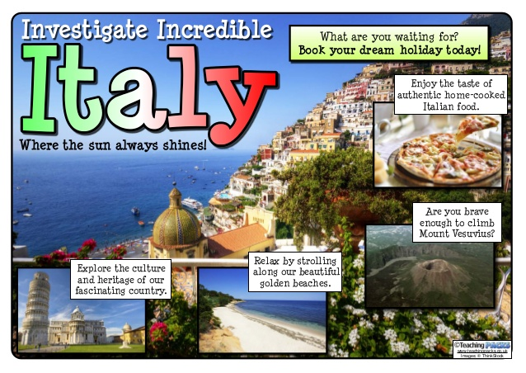

LUNCHTIME
Reading activities
Please choose a story to read independently or share together if you wish. A book of your own or from bug club. Did you enjoy it? Why? What were the characters like? Would you recommend it to a friend?

Helpwr Heddiw – game of your choice
PROFILE OF A FAMOUS AUSTRALIAN
There are lots of famous celebrities from Australia such as Hugh Jackman and Kylie Minogue to name two. Can you pick a famous Australian celebrity and write a fact file about them.

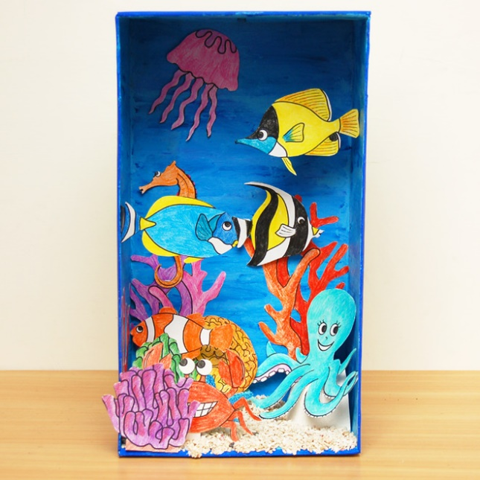
ART ACTIVITY

The Great Barrier Reef – Can you find out some information about the Great Barrier Reef.
Please make a powerpoint and then you can choose to make: a coral reef box or a coral relief painting/ collage.
The link below shows instructions for a coral box.
https://www.firstpalette.com/craft/coral-reef-diorama.html

Friday
Maths – supermovers and a game from ictgames or ttrockstars.
A postcard – Can you pick an Australian city and write a postcard home.
On the front draw or copy and paste images. On the back write the senders address on the left hand side and your message on the other. Include things such as: the weather, places you’ve been, things you’ve see and what you’ve eaten.

SNACK

Australia love to play sport and are always successful in the Olympics. Can you list the sports you know they play in Australia and find out others you weren’t aware of.
Sydney held the Olympics in 2000. Can you design a pic collage poster advertising the games.

LUNCH
Reading activities - Please choose a story to read independently or share together if you wish. A book of your own or from bug club. Did you enjoy it? Why? What were the characters like? Would you recommend it to a friend?

Helpwr Heddiw – a welsh game of your choice.
AUSTRALIAN WILDLIFE
Australia has some amazing wildlife, with animals you wont find anywhere else in the world. Carry out some research on the many different animals you would find there. What animals are the most deadly and which are the most endangered?
Can you make a powerpoint on Australian animals and write about your favourite animal.

Thank you. Please do what you can manage.
Mr Williams

