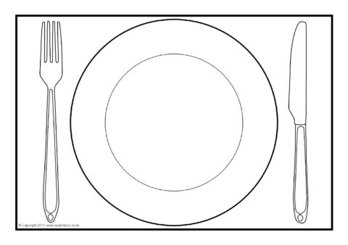

Draw a healthy meal . It could be breakfast, dinner or tea.