6
5
4
3
2
1
 | Apple | Banana | Grapes | Orange
Favourite Fruits

Remember, you can only choose one, your favourite!
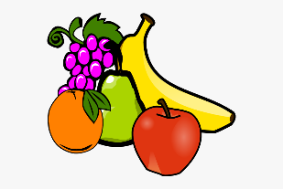
Colour in a block when someone chooses that fruit as their favourite.
Remember , you can ask people over the fence next door, you can phone people to ask
or ask people if you see them on your walk.

