Week beginning 29th June 2020
Hi everyone,
I hope you are all well and keeping safe. It is lovely to see the work that is sent.
Please feel free to send any work or photos to me on dojo or on hwb. My hwb email is WilliamsS1794@Hwbcymru.co.uk
Chapter 8 of Kensukes Kingdom is on the school app.
Thursday
Maths
Intro
- use supermovers as a warm up.
- Choose some games to play from ictgames.com, topmarks or themathsfactor.com
- Please visit Maths Gareth Metcalfe lesson – Thursday 02 July or BBC Bitesize Maths Daily Lessons.
Literacy
Kensuke’s Kingdom
Revisit Chapter 8 and answer the following questions. You may wish to read a bit now and a bit later on.
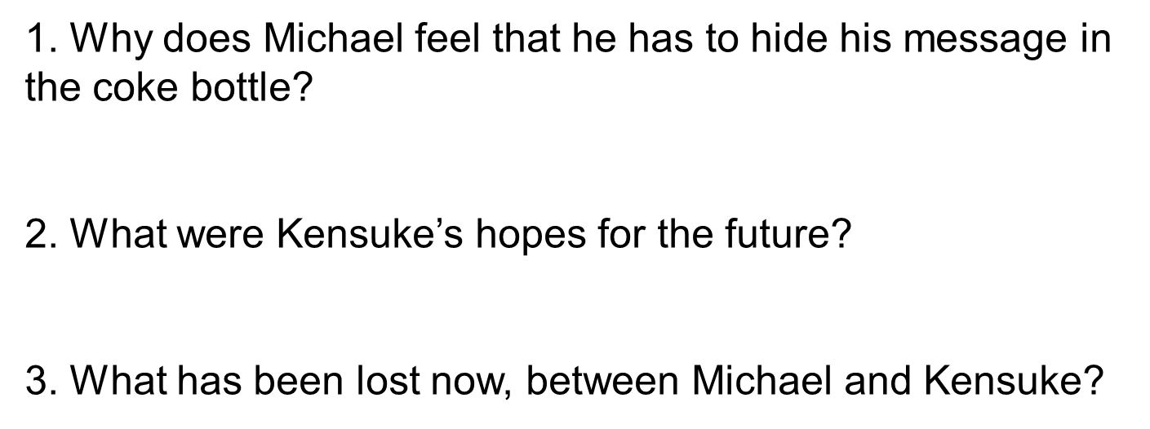
- Writing task – can you pretend you are lost at sea. Can you write a message in a bottle.

LUNCHTIME
Reading activities
Please choose a story to read independently or share together if you wish. A book of your own or from bug club. Did you enjoy it? Why? What were the characters like? Would you recommend it to a friend?
Welsh Helpwr Heddiw session and welsh lesson
Helpwr Heddiw session – choose from Mr Taten game, guess who game, language mat conversation or mobile phone conversations.

WELSH LESSON AND TASK
Asking for items. Revisit language patterns covered earlier in the year. Have a conversation with a family member and then write out a little script.

e.g..
Ant : Bore da, sut wyt ti? Good morning, how are you?
Dec : Bore da, Dw i’n iawn diolch. A ti? Good morning, I’m fine thank you. And you?
Ant : Ga i hufen ia plis? Can I have an ice cream please?
Dec: Wrth cwrs, pa fath? Of course, what type?
Ant: Ga i hufen ia siocled plis? Can I have a chocolate ice cream please?
Dec: Dyma ti. Here you go.
Ant: Diolch. Thank you.
Dec: Croeso You’re welcome.

You could use pizzas or sandwiches too.
Ice cream flavours.
Mefus = strawberry Siocled = chocolate fanila = vanilla
Pizzas/ Sandwiches
Caws = cheese Tomato = tomato Ham = ham Pinafal = pineapple tiwna = tuna
Cyw iar = chicken
Revisit the conversations you had last week asking for food in a shop/ café and this week. This week add : Have you got? Anything else?
e.g.

Bore da, oes gen ti ……? Good morning have you got…...?
Oes, mae gen i……….. Dyma ti. Yes, Ive got….. Here you go.

Nag oes, does gen i ddim ……… No, I haven’t got….

Rhywbeth arall? Something else?

Friday
Maths – supermovers – some videos of your choice.
Games of your choice from ictgames.com, topmarks or themathsfactor.com
- Please visit Maths Gareth Metcalfe lesson – Friday 03 July or BBC Bitesize Maths Daily Lessons.

SNACK
Literacy – Kensuke’s Kingdom

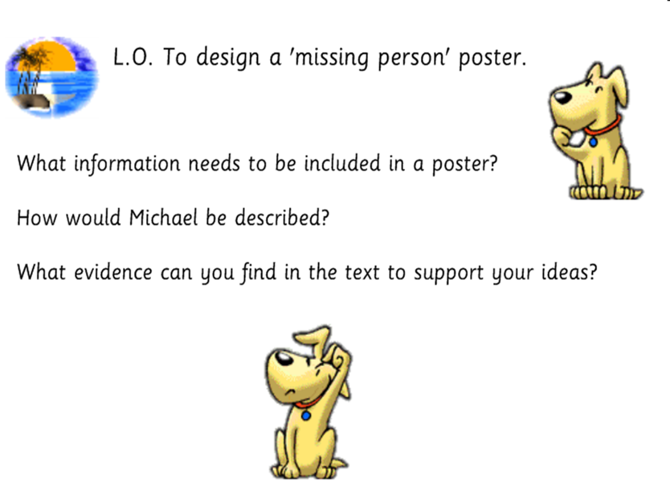

LUNCH
Reading activities - Please choose a story to read independently or share together if you wish. A book of your own or from bug club. Did you enjoy it? Why? What were the characters like? Would you recommend it to a friend?
Welsh Helpwr Heddiw – Pick a game of your choice from the ones we have been doing together.

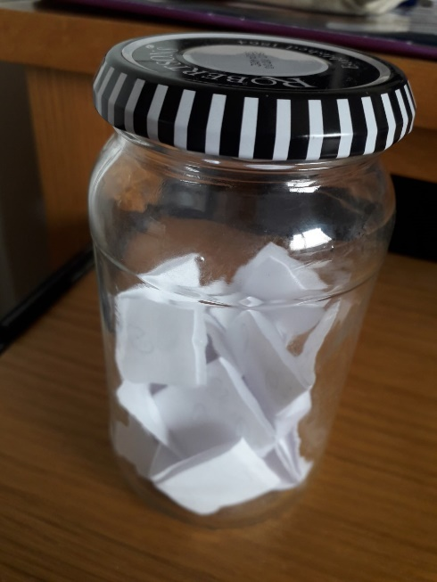
PSHE –

If you haven’t already, please start a post lockdown jar of things you would like to do when lockdown is over or things get eased. You can bring it to school soon to share some of your wishes with your classmates.

Can you also please make a list of things you have seen in your local area and across the country/ world that you think have been positive and or kind. You can also bring this to school to help make some posters.

P.E. – A daily walk – it could be the daily mile or a run or you could make up your own games with your family. There is also a weekly Active Wrexham challenge.
I’d love to see photos of you being active.

Thank you. Please do what you can manage.
Mr Williams

