Year 1 Topic W/C 8th June

- Find a recipe that you would like and make a shopping list of the ingredients you need, adding the prices of the items you need either using online shopping or asking your family.
e.g.
Shopping List for Chocolate cake

Flour | 45p
eggs | £1.00
butter | £1.20
cocoa powder | £2.00
caster sugar | £1.10
icing sugar | £1.70
chocolate sprinkles | £1.00

- Design a front cover of a book about your favourite thing e.g. a book about Frozen, a book about football, a book about animals.

- Practise asking your family how they are in Welsh ‘Sut wyt ti?’ pronounced sit oo ee tee, using these answers…
Bendigedig (fantastic)
Go lew (ok, not good but not bad)
Dw i’n drist (sad)
Dw i’n hapus (happy)
Dw i’n sâl (poorly)
Da iawn (very good)
Ofnadwy (terrible)
- Make masks for some of these feelings or draw pictures or take photographs of your own face/ someone in your family’s face.
- Make some money dominoes . Draw around coins on one side and write an amount on the other.
e.g.
5p

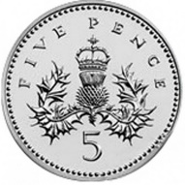 | 10p
 | 15p
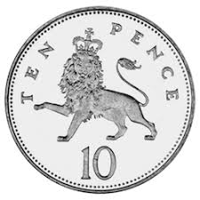 | 8p
 | 21p
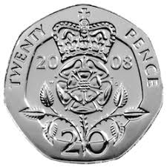 | 70p
 | £1.00
 | £2.00
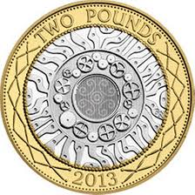 | 3p

