Year 1 Maths W/C 8th June
- This week’s work will be on 2d shape.
- Watch this clip on Bitesize about 2d shape
https://www.bbc.co.uk/bitesize/topics/zjv39j6/articles/ztpwdmn
- Go on a ‘shape hunt’ in your house and see which of these shapes you can find.
triangle 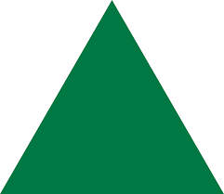
square
circle
rectangle
semi-circle
pentagon
hexagon 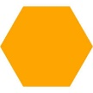

- Make your own picture using shapes…
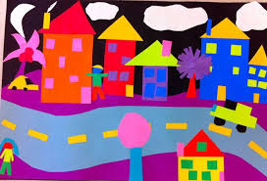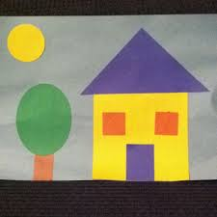

- Play these shape games-
https://www.topmarks.co.uk/ordering-and-sequencing/shape-patterns
https://www.topmarks.co.uk/early-years/shape-monsters
http://vtcpsa.hwb.wales.gov.uk/maerdy_2d/e_index.html

- Play shape bingo
Colour and cut out some 2d shapes, making different colours for each shape e.g. two red triangles, two green triangles, make a bingo board, splitting a piece of paper into 4 , put 4 shapes on the board and the rest into a box or bag. Take a shape out at a time and describe what the shape is like …
How many sides does it have?
How many corners does it have?
How many sides does it have?
Are its sides curved or straight?

(there is a version on Twinkl if you have access to a printer but it is easy, and more fun, to make your own!

