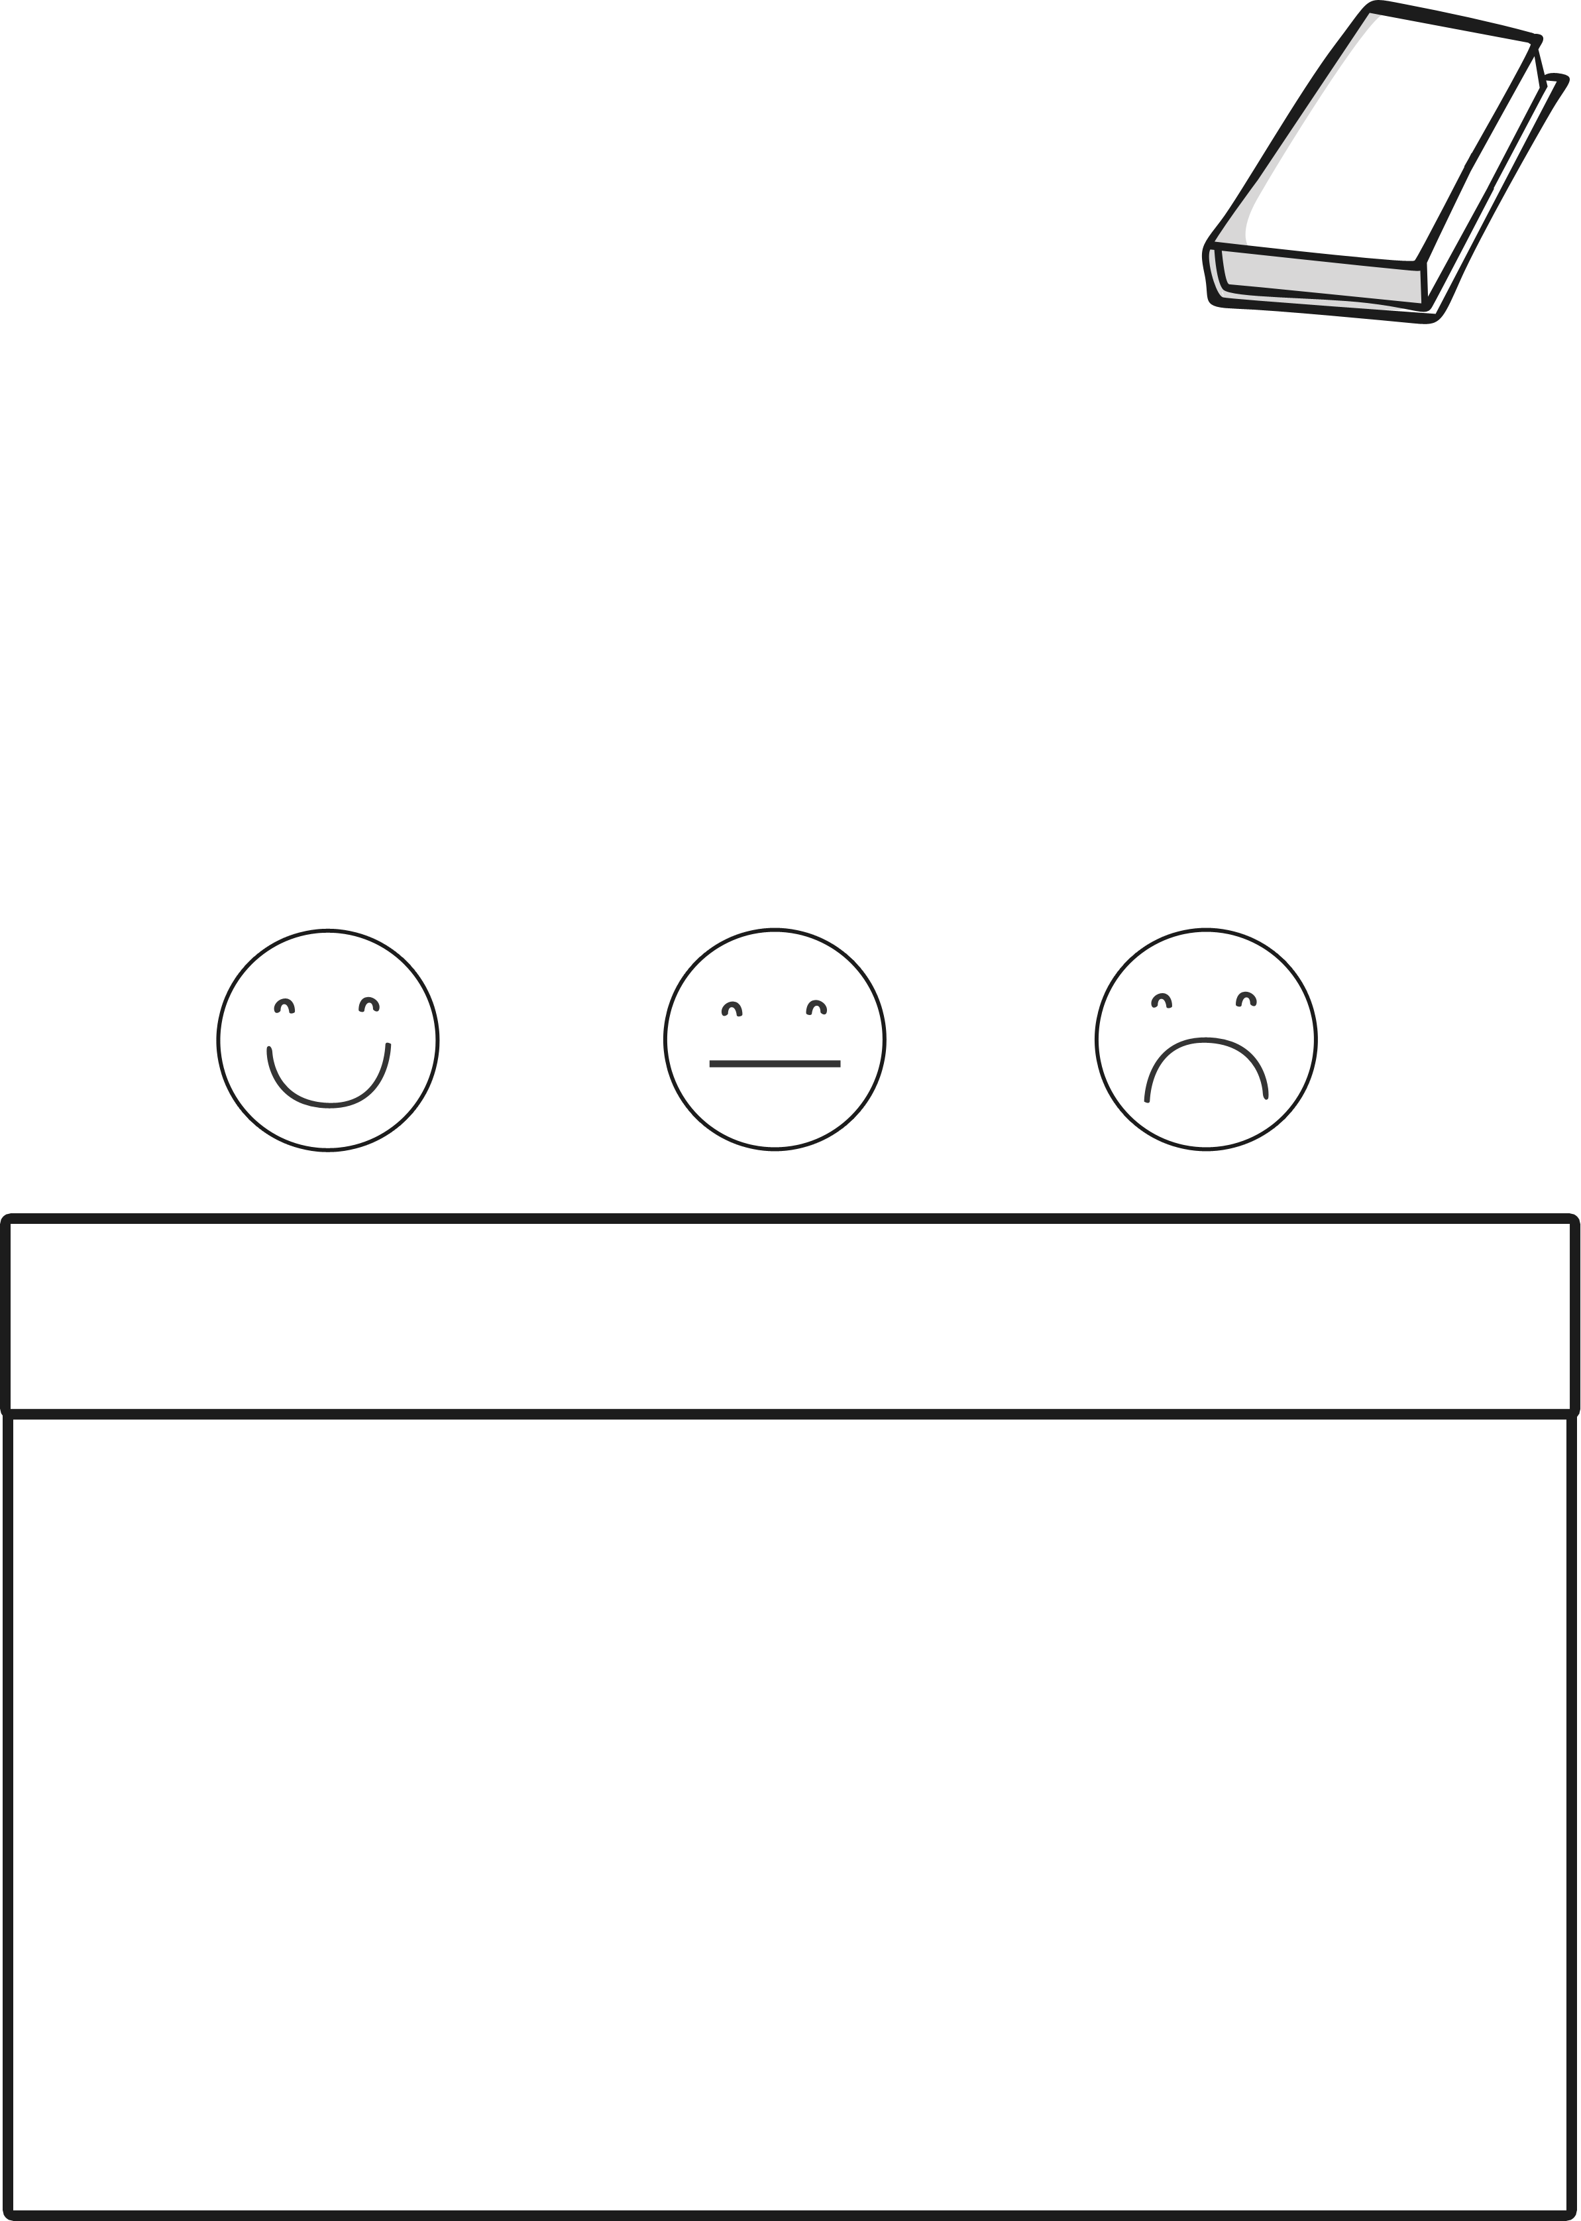
My Book Review
Name: ___________
Date: ____________
Book Title: A Squash and a Squeeze by Julia Donaldson

How did you feel about this book?
(Colour in the face)
Now draw your favourite part of the book.

