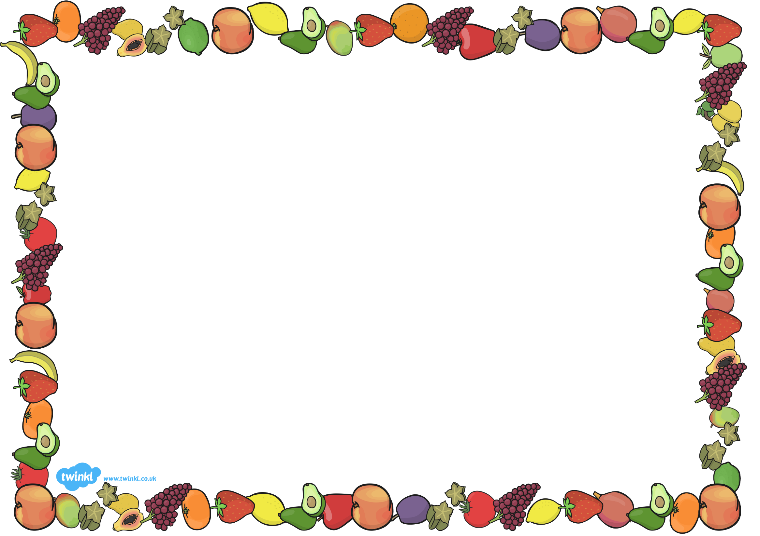
Year 2
15th- 19th June 2020 Health & Well Being Week
1  Look at the ‘Healthy Living’ PowerPoint.  Create a poster to show people how to stay healthy. | 2  Try some new healthy foods, take a pic and send to Mrs Ellis on Dojo | 3  Fill in the ‘I am an amazing person’ sheet and write down all the reasons why you are amazing ! | 4  Look at the ‘Healthy & Unhealthy lunchbox’ poster. Design a healthy lunchbox, remember to include a variety of foods  (2 resources for this task) | 5  Have a go at the  Joe Wicks  Workout cards
6  Mindfulness Activity sheets | 7  Write some instructions on how to wash your hands | 8  Play  ‘Fitness Bingo’  ( 3 resources for this task) | 9  Paint/draw a picture of your favourite place that you can’t wait to go to !  Send it to me on Dojo.  Mine is the beach x | 10  Friendship Tree  Draw and write the names of your special friends onto your Friendship Tree. You can add leaves onto your tree if you wanted to
11  Design a healthy meal.  It could be breakfast, dinner or tea. | 12  ‘Sun, Sea and Beach Safety’  Reading Comprehension  (Only print the sheets you need) | 13  Healthy Eating Sorting Activity –  Sort the foods onto the different plates | 14  Can you make an obstacle course in your garden ?  Time yourself and take the challenge to see if you can beat your record ! | 15  Create a poster to remind children to bring in a healthy snack for Breaktime in school
This week, we will be doing some different activities to remind us of the importance of staying healthy and looking after our wellbeing.
Choose some activities from the table below :
Activities with a number in red may have a PowerPoint to watch and/or activity sheets to print off.

