Year 4 Week beginning 15th June 2020 – HEALTHY WEEK
Hi everyone,
I hope you are all well and keeping safe.
Please feel free to send any work or photos to me on dojo or on hwb.
My hwb email is WilliamsS1794@Hwbcymru.co.uk
Thursday
Maths
Intro – use supermovers as a warm up. Choose some games to play from ictgames.com, topmarks or themathsfactor.com
https://www.bbc.co.uk/teach/supermovers/ks2-collection/zr4ky9q

- Please complete the Healthy Eating Code Breaker sheet.
Literacy
- Write a healthy eating poem. It could be a rap poem, rhyming poem, or a kenning.

LUNCHTIME
Reading activities
Please choose a story to read independently or share together if you wish. A book of your own or from bug club. Did you enjoy it? Why? What were the characters like? Would you recommend it to a friend?

Welsh Helpwr Heddiw session and welsh lesson
Helpw Heddiw session – choose from Mr Taten game, guess who game, language mat conversation or mobile phone conversations.
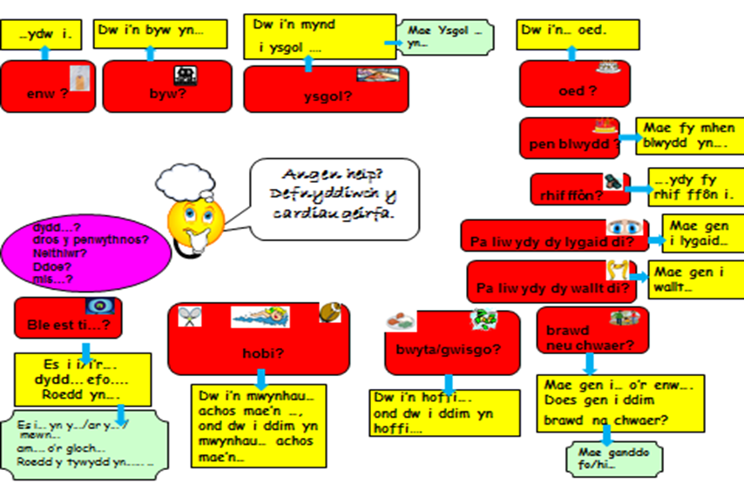
We have welsh Helpwr Heddiw session each day when the class helper plays games and takes the role of the teacher and Thursday is our welsh lesson.

WELSH LESSON AND TASK
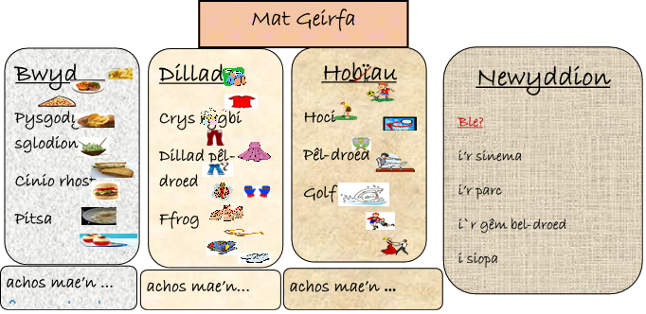
- Please look at the attached vocabulary sheets for different welsh food and drink.
- Have a conversation about what you like and dislike.
- Try and make extended sentences by using: and, or, but.

- Using the welsh week template make a diary of healthy meals you could have.

Friday
Maths
Intro – use supermovers as a warm up. Choose some games to play from ictgames.com, topmarks or themathsfactor.com
https://www.bbc.co.uk/teach/supermovers/ks2-collection/zr4ky9q

Healthy Eating Top Trump Cards
There are a number of ways you can use them.
Why not play top trumps but discuss if a low or high number would be best in certain cases.
Sort them into healthy and unhealthy piles.
Make a healthy meal.
Make a venn diagram.
Sort categories such as amount of fat from lowest to highest etc,
SNACK
Literacy – Diary writing/ story.
Imagine you are about to take part in the olympics (choose your sport), or play in the FA Cup final at Wembley, or take part in a gymnastics competition. You can choose another sporting event if you wish.
Can you write: a diary of what you did leading up to the event or a story about the actual event. What did you eat, how did you train for it, how did you feel before, during and after etc.
Remember – write in the past tense, chronological order, first person.

LUNCH
Reading activities
Please choose a story to read independently or share together if you wish. A book of your own or from bug club. Did you enjoy it? Why? What were the characters like? Would you recommend it to a friend?

Welsh Helpwr Heddiw – Pick a game of your choice from the ones we have been doing together.

P.E.

Healthy Eating for a sports person activity
- Look at the Eat Well plate powerpoint
- Imagine an athlete is preparing for a race and can only eat healthy foods leading up to the event or a footballer training for a competition.
- Can you pick some meals for him or her to eat that will help them do well.
If I have a running race, I try to drink more water than usual a few days before and also lots of carbohydrates like pasta, potatoes and bread. A banana and porridge on the morning of the race is also useful as it helps give energy during the race. Too much sugar is bad for you but a few jelly babies or haribo in my pocket also help to give some energy in the form of glucose.

A daily walk, jog or run with the family. You may like to do the Active Wrexham challenge too.

Thank you. Please do what you can manage.
Mr Williams

