Week beginning 8th June 2020
Hi parents ,
I hope you are all well and keeping safe. The weather has been glorious. Very unusual to have so little rain.
Please feel free to send any work or photos to me on dojo or on hwb. My hwb email is WilliamsS1794@Hwbcymru.co.uk
I have attached the next chapter of Kensukes Kingdom to dojo and the school app/website.
Thursday
Maths
Intro – use supermovers as a warm up. Choose some games to play from ictgames.com, topmarks or themathsfactor.com
Activity – Revisist the concept of perimeter.
- Look together at the powerpoint. Guide to Area and perimeter.
Just focus on perimeter – the outside of a shape today. Pages 1,5, 6 and 7.
- Find some squares and rectangles around the home/ garden e.g. a book front cover, front of a cereal box etc.
Measure the sides and write down the perimeter.
- Playground perimeter – look at the plan of a playground on page 1 and write down the perimeter of each area using the squares to help.
Literacy
Kensuke’s Kingdom – Chapter 5
- After reading chapter 5 of Kensukes Kingdom last week, can you describe Kensuke? Describe Kensuke’s appearance and clothes.
Can you draw a picture of what you think Kensuke would like like from the description given in the story?
Can you answer the following questions:
- Why is Kensuke angry and why has he put out the fire?
- Can you find the adjectives the author has used to describe Kensuke?
- Which words or details emphasise that Kensuke is old?
- Can you find some verbs (doing words) that convey Kensuke’s emotions?

LUNCHTIME
Reading activities
Please choose a story to read independently or share together if you wish. A book of your own or from bug club. Did you enjoy it? Why? What were the characters like? Would you recommend it to a friend?

Welsh Helpwr Heddiw session and welsh lesson
Helpw Heddiw session – choose from Mr Taten game, guess who game, language mat conversation or mobile phone conversations.
We have welsh Helpwr Heddiw session each day when the class helper plays games and takes the role of the teacher and Thursday is our welsh lesson.

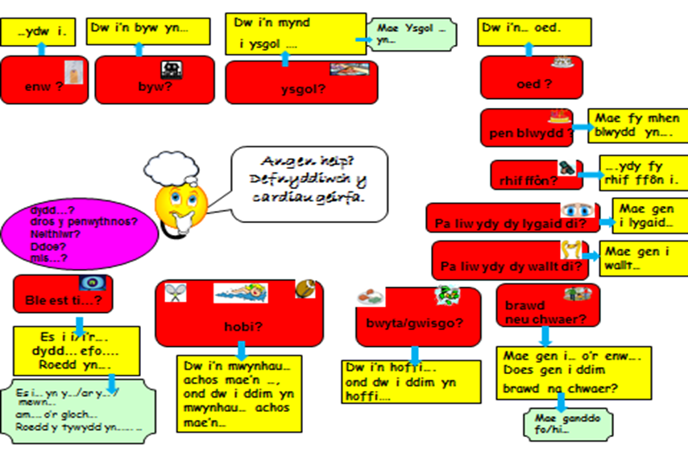

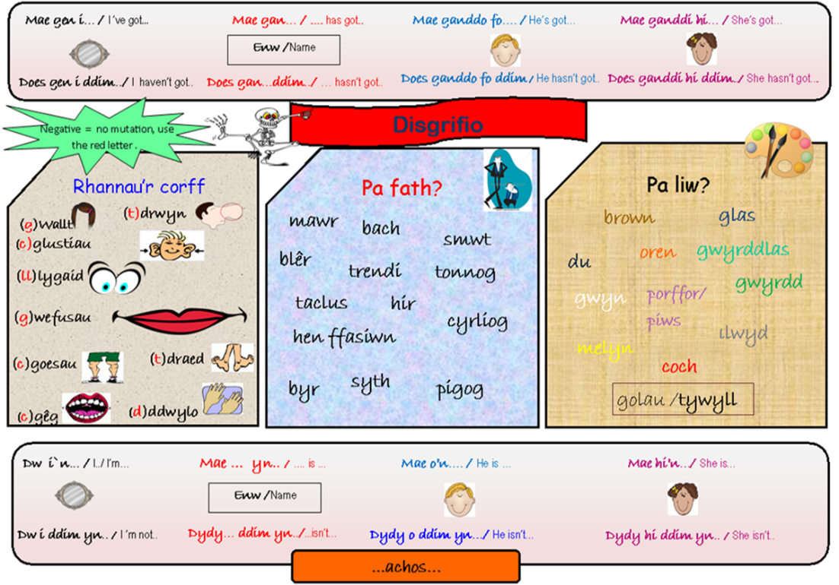
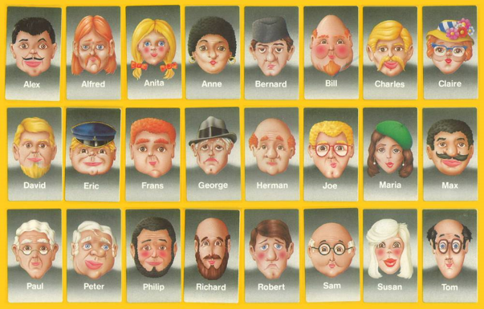

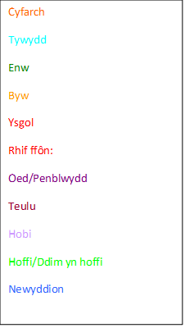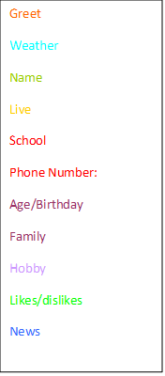
Make their own conversation phone cards. Fill in 2 or 3 phone templates or in books. Could be friends or celebrities and then ask questions using the language mats to help if needed.

WELSH LESSON AND TASK
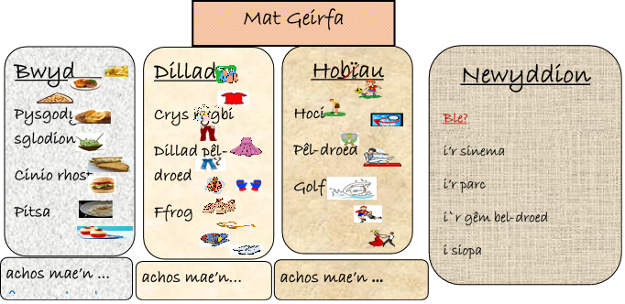

Expressing likes and dislikes using and, or, but,

A = and neu = or ond = but

Talk about food and hobbies.
e.g.
Beth wyt ti’n hoffi fwyta? What do you like to eat?
Beth ydy dy hobi di? What are your hobbies?

Dw i’n hoffi fwyta byrgr a sglodion ond dw i ddim yn hoffi cyrri = I like eating burger and chips but I don’t like curry.

Dw i’n hoffi chware pel droed a criced = I like playing football and cricket.

Dw i ddim yn hoffi tenis neu golf = I don’t like tennis or golf.

- Revisit what you did last week using and, or and but and write it as a conversation between between two people.
- Make a little questionnaire for your family to find out most popular sport or favourite pizza?
Wyt ti’n hoffi? Do you like? Ydw = yes Nag ydw = no
Pitsa caws a tomato = cheese and tomato pizza. Pitsa cyw iar = chicken pizza Pitsa ham a pinafal = ham and pineapple pizza Pitsa Peperoni = pepperoni pizza

P.E.
A daily walk, jog or run with the family or why not try this activity spelling out your name and the names of your family with the matching actions. You may like to do the Active Wrexham challenge too.

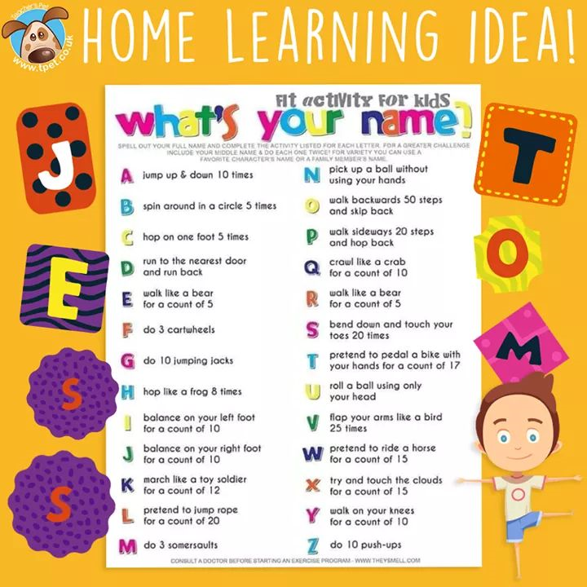

Friday
Maths – supermovers – some videos of your choice. Games of your choice from ictgames.com, topmarks or themathsfactor.com
- Perimeter – revisit slides from yesterday if needed.
- Design your own playground and write the perimeter for the different areas.
- Complete the worksheets – work out the perimeter of the different rectangles 1 dot = sheet 1 2 dot = sheet 2 3 dot= sheet 3

SNACK
Literacy – Kensuke’s Kingdom
Please read Chapter 6 and answer the following questions.

- How does Michael feel in this chapter?
- How does it make him feel towards Kensuke?
- How can the weather affect both feelings and actions?
- I wonder why Kensuke behaves like he does?
It must be hard for Michael being alone on an island with a strange person. What would you do to stop yourself from bored? Can you imagine you are on the island and write one page of a diary of what you did?

LUNCH
Reading activities
Please choose a story to read independently or share together if you wish. A book of your own or from bug club. Did you enjoy it? Why? What were the characters like? Would you recommend it to a friend?

Welsh Helpwr Heddiw – Pick a game of your choice from the ones we have been doing together.

PSHE – The box of some emotions that appeared in Chapter 5 of Kensuke’s Kingdom.
Can you discuss what they mean and write a sentence using each word or describe how you or Michael have experienced one of those emotions.
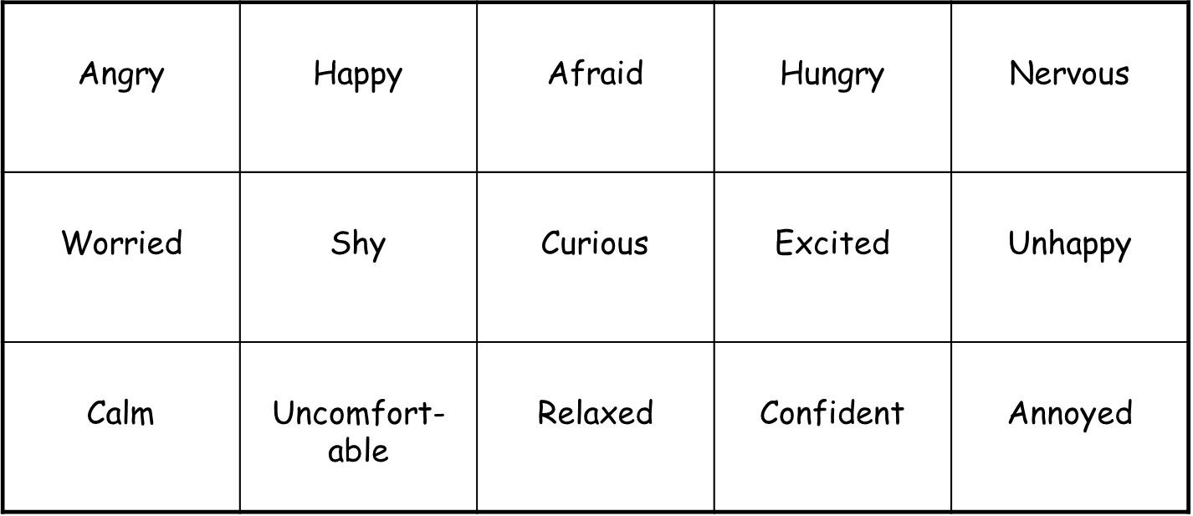
Thank you. Please do what you can manage.
Mr Williams

