Year 4 Week beginning 22nd June 2020
Hi everyone,
I hope you are all well and keeping safe. It is lovely to see the work that is sent.
Please feel free to send any work or photos to me on dojo or on hwb. My hwb email is WilliamsS1794@Hwbcymru.co.uk
Chapter 7 of Kensukes Kingdom is on the school app.
Thursday
Maths
Intro – use supermovers as a warm up. Choose some games to play from ictgames.com, topmarks or themathsfactor.com
Activity – Revisit the concept of perimeter.
- Look again at the area and perimeter powerpoint. Scroll back to two weeks ago on the class wall or on school website. Remind yourself what perimeter is (outside of the shape) and focus today on the area slides. (the inside of a shape)
Just focus on perimeter – the outside of a shape today. Pages 1,5, 6 and 7.
- Find some squares and rectangles around the home/ garden e.g. a book front cover, front of a cereal box etc. Work out the area today. You could use the same shapes as last week and write A = inside the shapes.
Measure the sides and write down the perimeter.
- Playground perimeter – look at the plan of a playgrounds again and this time work out the area of the shapes.
Literacy
Kensuke’s Kingdom
Revisit Chapter 6 from last week. It was put on the school app by Miss Evans last week if you didn’t get chance to read it.
- Why did Kensuke try to stop Michael from swimming? How does Michael interpret Kensukes actions and what is the real reason for Kensuke not wanting Michael to swim in the sea?

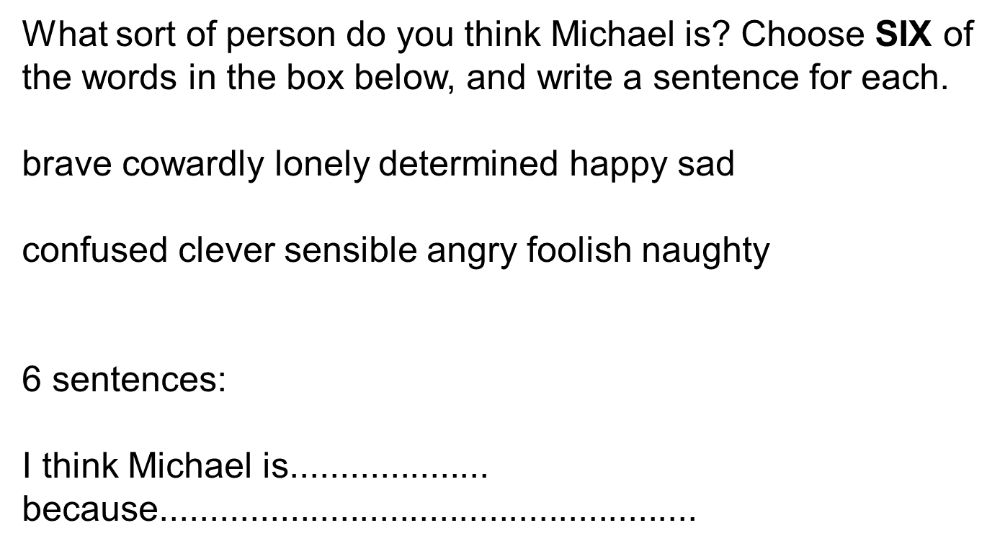

LUNCHTIME
Reading activities
Please choose a story to read independently or share together if you wish. A book of your own or from bug club. Did you enjoy it? Why? What were the characters like? Would you recommend it to a friend?

Start to read some of Chapter 7 of Kensuke’s Kingdom if you wish.
Welsh Helpwr Heddiw session and welsh lesson
Helpw Heddiw session – choose from Mr Taten game, guess who game, language mat conversation or mobile phone conversations.

WELSH LESSON AND TASK
Asking for items. Revisit language patterns covered earlier in the year. Have a conversation with a family member and then write out a little script.

e.g..
Ant : Bore da, sut wyt ti? Good morning, how are you?
Dec : Bore da, Dw i’n iawn diolch. A ti? Good morning, I’m fine thank you. And you?
Ant : Ga i hufen ia plis? Can I have an ice cream please?
Dec: Wrth cwrs, pa fath? Of course, what type?
Ant: Ga i hufen ia siocled plis? Can I have a chocolate ice cream please?
Dec: Dyma ti. Here you go.
Ant: Diolch. Thank you.
Dec: Croeso You’re welcome.

You could use pizzas or sandwiches too.
Ice cream flavours.
Mefus = strawberry Siocled = chocolate fanila = vanilla
Pizzas/ Sandwiches
Caws = cheese Tomato = tomato Ham = ham Pinafal = pineapple tiwna = tuna
Cyw iar = chicken

Friday
Maths – supermovers – some videos of your choice.
Games of your choice from ictgames.com, topmarks or themathsfactor.com
- Area – revisit slides from yesterday if needed.
- Add the areas of the parts of the playground you designed last week.
- Complete the area and perimeter sheet attached.
SNACK
Literacy – Kensuke’s Kingdom
- Read the rest of Chapter 7.
- How does Michael try to communicate with Kensuke before they can speak?

- Can you think of ways you can communicate without words?

- What Japanese custom does Michael adopt at the end of each day?

LUNCH
Reading activities
Please choose a story to read independently or share together if you wish. A book of your own or from bug club. Did you enjoy it? Why? What were the characters like? Would you recommend it to a friend?

Welsh Helpwr Heddiw – Pick a game of your choice from the ones we have been doing together.

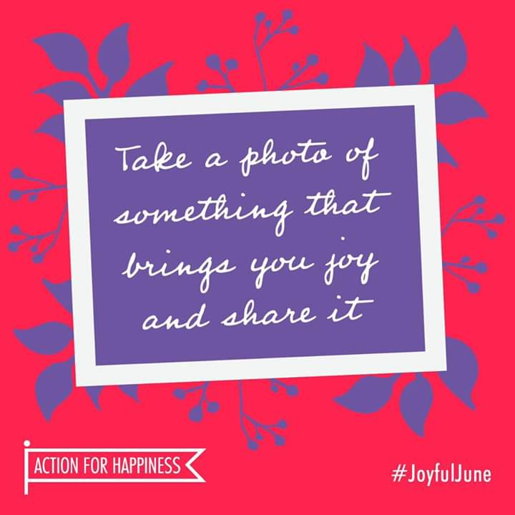
PSHE –
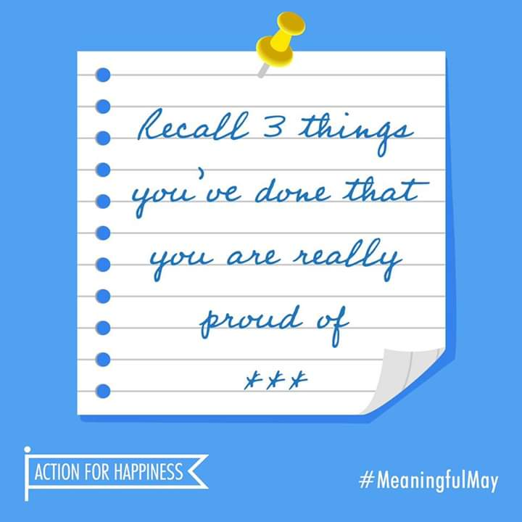
Mindful activities.
- Can you write down 3 things that you have done through lockdown that you are proud of. You may wish to make a pic collage or a drawing.
- Can you take a photo of something or a few things that bring you joy.

P.E. – A daily walk – it could be the daily mile or a run or you could make up your own games with your family. There is also a weekly Active Wrexham challenge.
I’d love to see photos of you being active.

Thank you. Please do what you can manage.
Mr Williams

