Literacy W/C 8th June
- Make your own sentences using these key words –
all, her, for, we, what, at , can, there, his,are.
e.g. All my family enjoy drawing pictures.
Ellie had egg and chips for her tea.
Hannah had sausage and chips for her dinner.
- Make a list of the colours of the rainbow and see how many things you can find that are each colour.
see my example
- Write a review of your favourite television programme.
see my example
- Write a letter to someone who is still going out to work.
see my example

- Find as many words as you can with these sounds –
y, j , k, th, ch, sh

Rainbow colours by Mrs. Goodwin

red | ladybird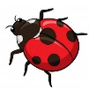 tomato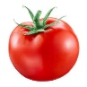 rose 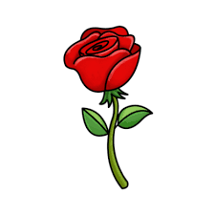
yellow | banana 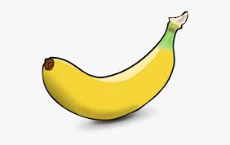 egg yolk chick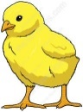
pink | Peppa pig 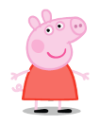 pink panther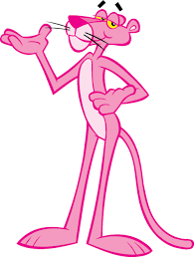 heart
green | leaf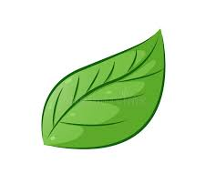cucumber 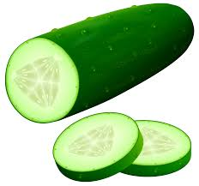 my car 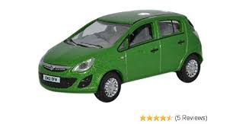
orange | orange 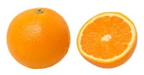 carrots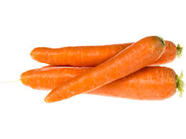 pumpkin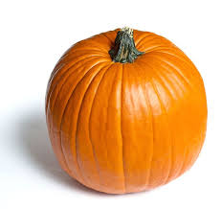
purple | grapes 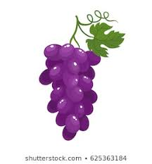 Tinky Winky 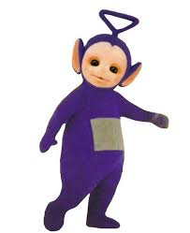 Miss Armstrong’s car 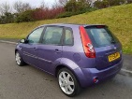
blue | sky Elsa’s dress cheese and onion crisps 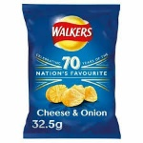

Television Programme Review
The programme is… Peppa pig
The characters in this programme are
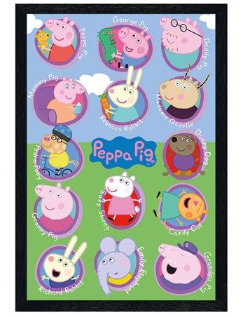
I like this programme because…
It makes me laugh and my nieces and nephew like it.
Marks out of 10

Ysgol Cefn Mawr
Plas Kynaston Lane
Cefn Mawr
Wrexham
LL14 3PY
Dear nurses and doctors,
Thank you for working hard to look after people who are poorly. Thank you for being kind to people in hospital and helping to make them better. I clap to say thank you to you every Thursday. This is my thank you rainbow.
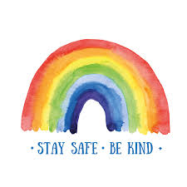
Diolch yn fawr,
Love from
Mrs. Goodwin

